**Athlete Leader-3D running and adventure game with multiple levels.**



#### M.WAQAS ABBASI (BSE193035)

#### Junaid Nazar (BSE193026)

#### Usama Umer (BSE193137)

**Supervised By**

**Sir Mudabbir Ali**

**Spring 2023**

**BS Software Engineering**

**Department of Software Engineering**

**Capital University of Science & Technology, Islamabad**

|  |  |  |
| --- | --- | --- |
|  | Project Report |  |

|  |  |  |  |  |  |  |
| --- | --- | --- | --- | --- | --- | --- |
| **VERSION** | | V 1.0 | |  | **NUMBER OF MEMBERS** | 3 |
|  | | | | | | |
| **TITLE** | Athlete Leader-3D endless running and adventure game. | | | | | |
|  | | | | | | |
| **SUPERVISOR NAME** | | | Sir Mudabbir Ali | | | |

|  |  |  |
| --- | --- | --- |
| **MEMBER NAME** | **REG. NO.** | **EMAIL ADDRESS** |
| M.WAQAS ABBASI | BSE193035 | [Bse193035@cust.pk](mailto:Bse193035@cust.pk) |
| JUNAID NAZAR | BSE193026 | [Bse193026@cust.pk](mailto:Bse193026@cust.pk) |
| USAMA UMER | BSE193137 | [Bse193137@cust.pk](mailto:Bse193137@cust.pk) |

|  |  |  |
| --- | --- | --- |
| **MEMBERS’ SIGNATURES** |  | |
|  |  | **Supervisor’s Signature** |
|  |  |
|  |  |

*Note 1: This paper must be signed by your supervisor*

*Note 2: The soft-copies of your project report, source codes, schematics, and executable should be delivered in a CD*

# Approval Certificate

This project, entitled as “Athlete Leader-3d running and adventure game having Competitive Environment” has been approved for the award of

**Bachelors of Science in Software Engineering**

**Committee Signatures:**

Supervisor: \_\_\_\_\_\_\_\_\_\_\_\_\_\_\_\_\_\_\_\_\_\_\_\_\_\_

(Mr. Mudabbir Ali )

Project Coordinator: \_\_\_\_\_\_\_\_\_\_\_\_\_\_\_\_\_\_\_\_\_\_\_\_\_\_

(Mr. Ibrar Arshad)

Head of Department: \_\_\_\_\_\_\_\_\_\_\_\_\_\_\_\_\_\_\_\_\_\_\_\_\_\_

(Dr. Nadeem Anjum)

# 

# Declaration

I/We, hereby, declare that “No portion of the work referred to, in this project has been submitted in support of an application for another degree or qualification of this or any other university/institute or other institution of learning”. It is further declared that this undergraduate project, neither as a whole nor as a part there of has been copied out from any sources, wherever references have been provided.

|  |
| --- |
| **MEMBERS’ SIGNATURES** |
|  |
|  |
|  |

# Acknowledgements

We owe special thanks to our supervisor Mr.Mudabbir Ali whose comprehensive guidance and thought provoking ideas helped us in the accomplishment of our project.We thank our supervisor for being available all the time when we needed guidance and help from them.

# Executive Summary

The game will have its own features which are never bring used before in any kind of such game like hurdles, bonus points, negative points of its own kind never used before and its own concepts which will make game more attractive. There will be plus point in term of health or coins. There will be also different modes of play for player like easy, normal, and hard and user can choose one of its own choices. Sprite that will be used in game will also have different function different from other games. So that game will be first of its kind.

**Table of Contents**

[Project Report ii](#_Toc135522318)

[Approval Certificate iii](#_Toc135522319)

[Declaration iv](#_Toc135522320)

[Acknowledgements v](#_Toc135522321)

[Executive Summary vi](#_Toc135522322)

[Chapter 1 1](#_Toc135522323)

[1. Introduction 1](#_Toc135522324)

[1.1. Project Introduction 1](#_Toc135522325)

[1.1.1. Game Design Document 1](#_Toc135522326)

[1.2. Existing Examples / Solutions 2](#_Toc135522327)

[1.3. Business Scope 3](#_Toc135522328)

[1.4. Useful Tools and Technologies 3](#_Toc135522329)

[1.5. Project Work Break Down 4](#_Toc135522330)

[1.6. Project Time Line 5](#_Toc135522331)

[Chapter 2 6](#_Toc135522332)

[2. Requirement Specification and Analysis 6](#_Toc135522333)

[2.1. Functional Requirements 6](#_Toc135522334)

[2.2. Non-Functional Requirements 7](#_Toc135522335)

[2.3. System Use Case Modeling 8](#_Toc135522336)

[2.3.1. Main Menu 9](#_Toc135522337)

[2.3.2. Obstacles 10](#_Toc135522338)

[2.3.3. Pause Menu 11](#_Toc135522339)

[2.3.4. Leaderboard 12](#_Toc135522340)

[2.3.5. Player data 13](#_Toc135522341)

[2.3.6. Misssion 14](#_Toc135522342)

[2.3.7. Score 15](#_Toc135522343)

[2.3.8. Mode Selection 16](#_Toc135522344)

[2.3.9. Start Game 17](#_Toc135522345)

[2.3.10. Quit 18](#_Toc135522346)

[2.4. System Sequence diagrams 19](#_Toc135522347)

[2.5. Domain Model 23](#_Toc135522348)

[2.6. Minimum Requirement 23](#_Toc135522349)

[2.7. Limitation and Constraint 24](#_Toc135522350)

[2.8. User Interface Design (Prototypes) 24](#_Toc135522351)

[Chapter 3 28](#_Toc135522352)

[3. System Design 28](#_Toc135522353)

[3.1. Software Architecture 28](#_Toc135522354)

[3.2. Class Diagram 30](#_Toc135522355)

[3.3. Sequence Diagram 31](#_Toc135522356)

[3.4. Entity Relationship Diagram 32](#_Toc135522357)

[3.5. Gameplay Diagram 33](#_Toc135522358)

[Chapter 4 34](#_Toc135522359)

[4. Software Development 34](#_Toc135522360)

[4.1. Coding Standards 34](#_Toc135522361)

[4.2. Development Environment 35](#_Toc135522362)

[4.3. Software Description 35](#_Toc135522363)

[4.3.1. Player Data Module 36](#_Toc135522364)

[4.3.2. Leaderboard Module 39](#_Toc135522365)

[4.3.3. GameOver Module 42](#_Toc135522366)

[4.3.4. Missions Module 45](#_Toc135522367)

[4.4. 3D/2D Objects, Terrain, & Scene Management (For Games based FYP) 49](#_Toc135522368)

[4.5. Software Minimum Requirement 51](#_Toc135522369)

[4.6. Software Limitations and Constraint 51](#_Toc135522370)

[4.7. General Assets 52](#_Toc135522371)

[4.7 Online Market Store 53](#_Toc135522372)

[Chapter 5 54](#_Toc135522373)

[5. Software Testing 54](#_Toc135522374)

[5.1. Testing Methodology 54](#_Toc135522375)

[5.2. Testing Environment 54](#_Toc135522376)

[5.3. Test Cases 55](#_Toc135522377)

[5.3.1. Test Case 1 55](#_Toc135522378)

[5.3.2. Test Case 2 56](#_Toc135522379)

[5.3.3. Test Case 3 57](#_Toc135522380)

[5.3.4. Test Case 4 58](#_Toc135522381)

[5.3.5. Test Case 5 59](#_Toc135522382)

[5.3.6. Test Case 6 60](#_Toc135522383)

[5.3.7. Test Case 7 61](#_Toc135522384)

[5.3.8. Test Case 8 62](#_Toc135522385)

[5.3.9. Test Case 9 63](#_Toc135522386)

[5.3.10. Test Case 10 64](#_Toc135522387)

[5.3.11. Test Case 11 65](#_Toc135522388)

[5.3.12. Test Case 12 66](#_Toc135522389)

[Chapter 6 67](#_Toc135522390)

[6. Software Deployment 67](#_Toc135522391)

[6.1. Installation / Deployment Process Description 67](#_Toc135522392)

[Plagiarism Report 69](#_Toc135522393)

[Report Approval Certificate 70](#_Toc135522394)

[Evaluator’s Feedback - Checklist 70](#_Toc135522395)

**List of Figures**

If the report contains figures or tables a list of these should be provided.

[Figure 1‑1 Work breakdown structure 4](#_Toc135467537)

[Figure 1‑2 Gant Chart 5](#_Toc135467538)

[Figure 2‑1 Use-case Diagram 8](#_Toc135467539)

[Figure 2‑2 Main Menu SDD 19](#_Toc135467540)

[Figure 2‑3 Obstacles SDD 20](#_Toc135467542)

[Figure 2‑4 Pause Menu SDD 20](#_Toc135467542)

[Figure 2‑5 Leaderboard SDD 21](#_Toc135467542)

[Figure 2‑6 Mission SDD 21](#_Toc135467542)

[Figure 2‑7 Player Data SDD 22](#_Toc135467542)

[Figure 2‑8 Score SDD 22](#_Toc135467542)

[Figure 2‑9 Athlete Leader Domain Model 23](#_Toc135467543)

[Figure 2‑10 Main Menu 24](#_Toc135467542)

[Figure 2‑11 Sound Menu 25](#_Toc135467542)

[Figure 2‑12 Mode Selection 25](#_Toc135467542)

[Figure 2‑13 GamePlay 26](#_Toc135467542)

[Figure 2‑14 Leaderboard 26](#_Toc135467542)

[Figure 2‑15 Tuotorial 22](#_Toc135467542)

[Figure 3‑1 Software Architecture Diagram 29](#_Toc135467544)

[Figure 3‑2 Class Diagram 30](#_Toc135467545)

[Figure 3‑3 Sequence Diagram 31](#_Toc135467546)

[Figure 3‑4 Entity Relationship Diagram 32](file:///C:\\Users\\WAQAS\\Desktop\\nrw%20format%20(Repaired).docx" \l "_Toc135467547)

[Figure 3‑5 Gameplay diagram 33](#_Toc135467548)

[Figure 4‑1 Character Model 49](#_Toc135467549)

[Figure 4‑2 Obstacles Model 49](#_Toc135467549)

[Figure 4‑3 Scene Menu 49](#_Toc135467549)

[Figure 4‑4 Main Menu Scene 49](#_Toc135467549)

[Figure 4‑5 Tuotorial Menu Scene 51](#_Toc135467549)

[Figure 4‑6 Premium Coins 52](#_Toc135467549)

[Figure 4‑7 Environment Assets 52](#_Toc135467549)

[Figure 4‑8 Hurdles 53](#_Toc135467549)

**List of Tables**

[Table 2‑1 Functional Requirements 6](#_Toc135467550)

[Table 2‑2 Non-Functional Requirement 7](#_Toc135467551)

[Table 2‑3 Use-case Main Menu 9](#_Toc135467552)

[Table 2‑3 Use-case Obstacles 10](#_Toc135467552)

[Table 2‑4 Use-case Pause Menu 11](#_Toc135467552)

[Table 2‑5 Use-case Leaderboard 12](#_Toc135467552)

[Table 2‑6 Use-case Player Data 13](#_Toc135467552)

[Table 2‑7 Use-case Mission 14](#_Toc135467552)

[Table 2‑8 Use-case Score 15](#_Toc135467552)

[Table 2‑9 Use-case Mode 16](#_Toc135467552)

[Table 2‑10 Use-case Start Game 17](#_Toc135467552)

[Table 2‑11 Use-case Quit 18](#_Toc135467552)

[Table 5‑1 Test Case-Main Menu 55](#_Toc135467553)

[Table 5‑2 Test Case-Mode Selection 55](#_Toc135467553)

[Table 5‑3 Test Case-Start Game 57](#_Toc135467553)

[Table 5‑4 Test Case-End Game 58](#_Toc135467553)

[Table 5‑5 Test Case-Obstacles 59](#_Toc135467553)

[Table 5‑6 Test Case-Pause Menu 60](#_Toc135467553)

[Table 5‑7 Test Case-Leaderboard 61](#_Toc135467553)

[Table 5‑8 Test Case-Mission 62](#_Toc135467553)

[Table 5‑9 Test Case-Score 63](#_Toc135467553)

[Table 5‑10 Test Case-Collision detection 64](#_Toc135467554)

[Table 5‑11 Test Case-Animator Controller 65](#_Toc135467555)

[Table 5‑12 Test Case-Player Data 66](#_Toc135467556)

This page is kept blank

# Chapter 1

# Introduction

This FYP is based on a 3d adventure game with new highly attractive assets and models that are never being used before in any such kind of game before that.. The game will be desktop based so that user does not feels any kind of difficulty while downloading or playing it a user can choose best option to play it which suits him most or which is best possible module for him.

## Project Introduction

The game will have its own features which are never bring used before in any kind of such game like hurdles, bonus points, premium coins of its own kind never used before and its own concepts which will make game more attractive. There will be obstacles in the way of the player player will have to cross these all obstacles to move next and to gain points if he fails to do so his life will be descreased. There will be also different modes of play for player like easy, normal, and hard and user can choose one of its own choices. Sprite that will be used in game will also have different function different from other games. So that game will be first of its kind.

### Game Design Document

A game design document (GDD) is a comprehensive blueprint or roadmap that outlines the various aspects and details of a video game's design. It serves as a central reference document for the development team, providing a clear understanding of the game's concept, mechanics, features, and overall vision. The GDD acts as a communication tool between different stakeholders, including designers, programmers, artists, and producers, ensuring everyone is aligned and working towards the same goal.

1. **Game Concept**

This Game involves different views and models of a city and cars model to bring attraction in game and leaderboard to make a competitive environment in game.

1. **Genre**

This Game is based on adventure genre.

1. **Target Audience**

There is not any specific target audience of game it is for every age of people.

1. **Game Flow**

Player is interacting with object through collider and different models and user interface for every kind of movement is added

1. **Project Scope**

This game will be more harder and entertaining as there will be hurdles in the way that are never used before in any game also increase in health will be possible which will be a big relief for a player so that he will work more harder to get health if it is at risk similarly there will be time restrictions to pass a level or certain phase of game if user fails to do so game will stop and player will die and if user passes time will be added.Every age group can play it no specific group definedeasy to understand by beginners to play.There is no limititaions for this game which makes it eassy to install and play.

## Existing Examples / Solutions

There are some of the existing examples of that kind of game like Temple Run, Subway Suffers etc. but they are available only in mobile based version,Athlete leader will be available in desktop. The game will be first of its kind as in games like him there are not any specific models used they uses background of forest, trees etc. but in that one we will use models of mountains and trees in game. There will be new and best features in that game that are never used before in any game. There are many concepts that are new and never used and will make game more interesting.

This game will be more harder and entertaining as there will be hurdles in the way that are never used before in any game also increase in health will be possible which will be a big relief for a player so that he will work more harder to get health if it is at risk similarly there will be time restrictions to pass a level or certain phase of game if user fails to do so game will stop and player will die and if user passes time will be added.

|  |  |
| --- | --- |
| C:\Users\WAQAS\AppData\Local\Microsoft\Windows\INetCache\Content.Word\pngaaa.com-6120262.png | Temple run is endless 3d game with a sprite running its way and monkey is chasing him with a lot of bonuses on way and coins to collect it is an endless running adventure game having hurdles on way and forest in its background. |

|  |  |
| --- | --- |
| C:\Users\WAQAS\Desktop\png-transparent-subway-surfers-iphone-android-subway-surfer-game-electronics-computer-wallpaper-thumbnail.png | Subway suffers is also an endless running game with hurdles and rewards on its way and many bonuses on crossing hurdles. |

## Business Scope

As we know that gaming industry is one of the growing industries and is most profitable and best earning industry now a days, there are very less games that are available for desktop of this genre but this game will finish that difficulty and will be available in desktop both. The background features of game will attract players toward nature. There is no limititaions for this game which makes it eassy to install and play.

## Useful Tools and Technologies

|  |  |
| --- | --- |
| C:\Users\WAQAS\Desktop\unity-logo-svg-768x768.jpg | Unity 3d game development engine is best development engine so far most of the most popular games like IGI, Hitman, and Pokémon etc. It is easy to install and requirements are very less and are easy to understand by new users and experts it can help to build web, mobile, desktop applications easily and efficiently with least complexities. |

## Project Work Break Down

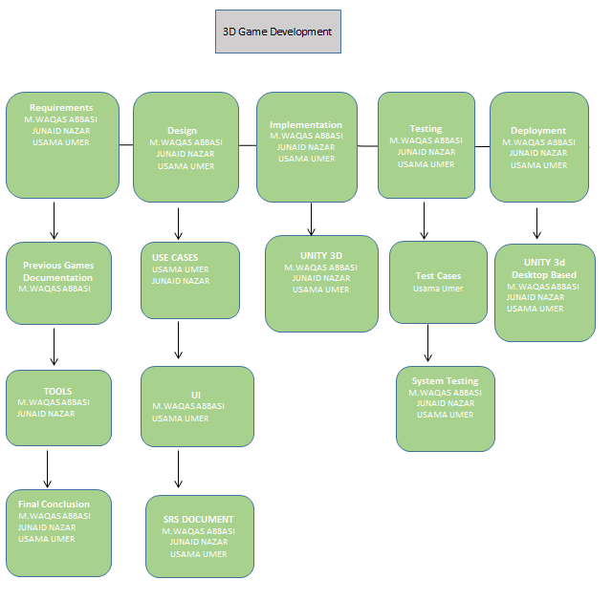

Figure 1‑1 Work breakdown structure

## Project Time Line

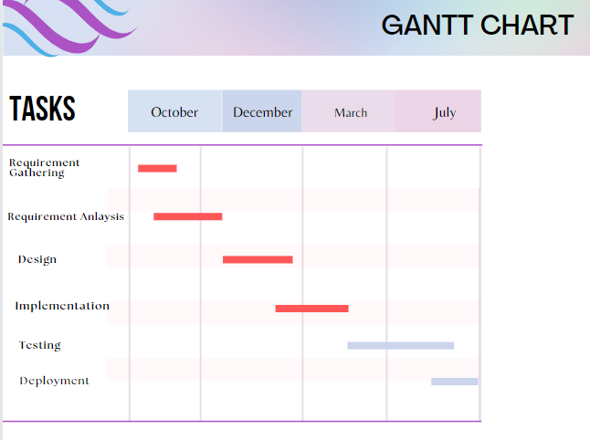

Figure 1‑2 Gant Chart

# 

# Chapter 2

# Requirement Specification and Analysis

Requirement Specification is describing the system that what he is going to do what it will behave. So in this Game we are going to provide entertainment to our users by allowing them to compete with each other by providing them different modules and functions and different modes to play according to their choice. This Game will also provide competition between different players and will have to login each time using accounts there will be simple method of players competition using leaderboard will be maintained accordingly. There will also be hurdles and on the way of the player that will be used as term of bonuses for player. There will also time restrictions for player which will bring more competition in game.

## Functional Requirements

A functional requirement defines a function of a system or its component. Functional requirements may be calculations, technical details, data manipulation and processing and other specific functionality that define what a system is supposed to accomplish.

Table 2‑1 Functional Requirements

|  |  |  |  |
| --- | --- | --- | --- |
| **S. No.** | **Functional Requirement** | **Type** | **Status** |
| 1 | Main Menu to be displayed at the start of game. | Core | Implemented |
| 2 | Sound functionality will be included in Main Menu for adjustment of sound | Core | Implemented |
| 3 | Different playing modes included in Main Menu to select different kind of modes of player’s choice. | Core | Implemented |
| 4 | Leaderboard included in Main Menu to show different kind of players score and rank. | Core | Implemented |
| 5 | Tutorial player can take if does not know how to play game. | Core | Implemented |
| 6 | Exit Button included if player want to stop playing and will end the game and stop game. | Core | Implemented |
| 8 | Obstacles in the way of game to bring difficulty for game to pass these hurdles to gain points and move to next level. | Core | Implemented |
| 9 | Models with animations in background of game. | Core | Implemented |
| 11 | Environment control of Player according to mode of game. | Core | Implemented |
| 12 | Animation applied on player sprite to make 3d movement of a player. | Core | Implemented |
| 13 | Colliders added to player to check collision with the hurdles. | Core | Implemented |
| 14 | Pause button on top if user wants to stop game. | Core | Implemented |
| 17 | Store Player Data for counting score of player and achieve missions. | Core | Implemented |
| 18 | Adjust game environment and add assets according to environment. | Core | Implemented |
| 19 | Add lightning in game as required to change theme of game. | Core | Implemented |
| 20 | Adjust camera angel according to sprite so that camera move along player. | Core | Implemented |
| 21 | Display the available occupied premium coin or life in game. | Core | Implemented |
| 22 | Deploy game for Desktop version. | Core | Implemented |

## Non-Functional Requirements

A non-functional requirement is a requirement that specifies criteria that can be used to judge the operation of a system, rather than specific behaviors. They are contrasted with functional requirements that define specific behavior or functions.

Table 2‑2 Non-Functional Requirement

|  |  |  |
| --- | --- | --- |
| **S. No.** | **Non Functional Requirements** | **Category** |
| 1 | System should process the game in minimum time. | Usability |
| 2 | System should perform specific function which is desired. | Usability |
| 3 | Leaderboard should update only that specific user ranking. | Security |
| 4 | Game should end on not passing hurdle by player three times. | Reliability |
| 5 | Game should stop on pause button click. | Reliability |

## System Use Case Modeling

A use case is a list of actions or event steps, typically defining the interactions between a role (known in the Unified Modeling Language as an actor) and a system, to achieve a goal. The actor can be a human or other external system. Game use cases are shown in the following the figure.

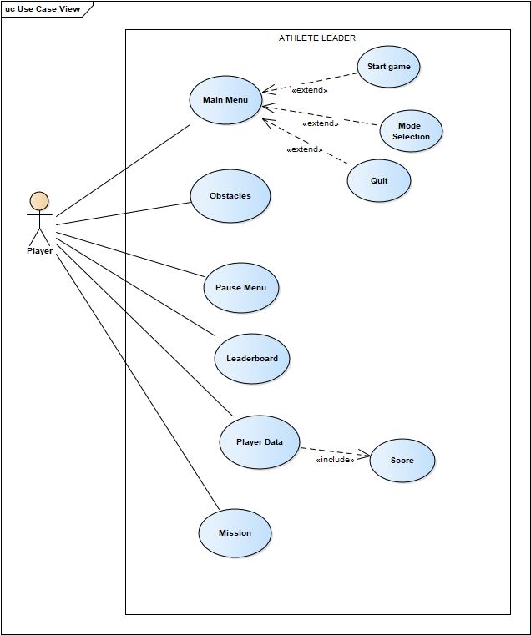

Figure 2‑1 Use-case Diagram

### Main Menu

In this use case description table explains what will be displayed first when user will click on the start button.This table explains features of the main menu.

Table 2‑3 Use-case Main Menu

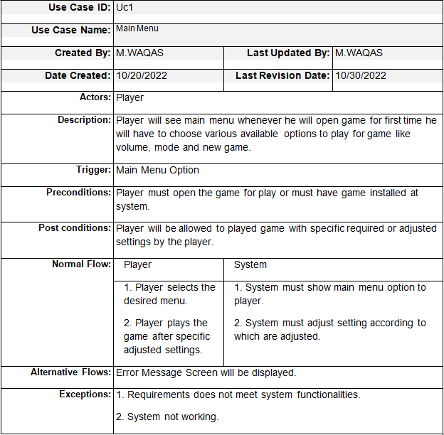

### Obstacles

In this use case description table explains that what kind of obstacles will come to the way of the player and what will be there points on passing these obstacles.

Table 2‑4 Use-case Obstacles

|  |  |  |  |
| --- | --- | --- | --- |
| **Use Case ID:** | Uc2 | | |
| **Use Case Name:** | Obstacles | | |
| **Created By:** | M.WAQAS | **Last Updated By:** | M.WAQAS |
| **Date Created:** | 10/20/2022 | **Last Revision Date:** | 10/30/2022 |
| **Actors:** | Player | | |
| **Description:** | Player will have to pass obstacles in the way that will come to get the bonus points and to move further on the track or get life to survive in the game. | | |
| **Trigger:** | Play Game Button | | |
| **Preconditions:** | Player must start playing game. | | |
| **Post conditions:** | Bonus points will be added in the current points of the system after gaining premium coins. | | |
| **Normal Flow:** | Player | System | |
| 1. Player plays the game and pass obstacles come to its way to gain points. | 1. System will add points in the total score of the player and leaderboard. | |
| **Alternative Flows:** | Obstacles error will be displayed. | | |
| **Exceptions:** | 1. Leader board got struck due to system error or internet miss connectivity. | | |

### Pause Menu

In this use case description table explains how pause menu will be displayed on the clicking pause button by player and what will be its effect on the game.

Table 2‑5 Use-case Pause Menu

|  |  |  |  |
| --- | --- | --- | --- |
| **Use Case ID:** | Uc3 | | |
| **Use Case Name:** | Pause Menu | | |
| **Created By:** | M.WAQAS | **Last Updated By:** | M.WAQAS |
| **Date Created:** | 10/20/2022 | **Last Revision Date:** | 10/30/2022 |
| **Actors:** | Player | | |
| **Description:** | Player will click on pause button to select options available to him in pause menu on clicking pause button game will stop at current state and pause menu will be displayed having resume and main menu button. | | |
| **Trigger:** | Pause Button | | |
| **Preconditions:** | Player must be playing game. | | |
| **Post conditions:** | Pause Menu will be displayed to player from which he can choose desired options. | | |
| **Normal Flow:** | Player | System | |
| 1. Player plays the game and click on pause button while playing game. | 1. System will display pause menu and pause the game. | |
| **Alternative Flows:** | Game loading error will be displayed. | | |
| **Exceptions:** | 1. Leader board got struck due to system error or internet miss connectivity. | | |

### Leaderboard

In this use case description table explains functionality of the lraderboard how rank name and score of a player and adjust ranking accordingly will be maintained in leaderboard and how leaderboard will be maintained.

Table 2‑6 Use-case Leaderboard

|  |  |  |  |
| --- | --- | --- | --- |
| **Use Case ID:** | Uc4 | | |
| **Use Case Name:** | Leaderboard | | |
| **Created By:** | M.WAQAS | **Last Updated By:** | M.WAQAS |
| **Date Created:** | 10/20/2022 | **Last Revision Date:** | 10/30/2022 |
| **Actors:** | Player | | |
| **Description:** | Leaderboard will be displayed once game is completed when player will got out player will have rank, number and score on it with other players name and score also displayed on it. | | |
| **Trigger:** | Run Button | | |
| **Preconditions:** | Player must get out after playing game. | | |
| **Post conditions:** | Player will have leaderboard displayed at end of game having score and rank of player displayed on it. | | |
| **Normal Flow:** | Player | System | |
| 1. Player plays the game and get out. | 1. System will maintain leaderboard after using player data while playing game. | |
| **Alternative Flows:** | Blank leaderboard with no rank and name will be displayed. | | |
| **Exceptions:** | 1. Leader board got struck due to system error. | | |

### Player data

In this use case description table that what player data will be stored in game it includes name and score of player that can be later used for maintain of the leaderboard.

Table 2‑7 Use-case Player Data

|  |  |  |  |  |
| --- | --- | --- | --- | --- |
| **Use Case ID:** | Uc5 | | | |
| **Use Case Name:** | Player Data | | | |
| **Created By:** | M.WAQAS | **Last Updated By:** | | M.WAQAS |
| **Date Created:** | 10/20/2022 | **Last Revision Date:** | | 10/30/2022 |
| **Actors:** | Player | | | |
| **Description:** | Player data will have player mission requirements stored in it for each player and specific missions to be displayed for player. | | | |
| **Trigger:** | Run button. | | | |
| **Preconditions:** | Player must achieve required requirements while playing game. | | | |
| **Post conditions:** | Player can claim reward after achieving mission. | | | |
| **Normal Flow:** | Player | | System | |
| 1. Player plays game and reaches requirements. | | 1. System will update next mission. | |
| **Alternative Flows:** | Leaderboard to be displayed if mission not achieved. | | | |
| **Exceptions:** | 1. Game got struck due to system error. | | | |

### Misssion

In this use case description table explains that how mission pop up will be displayed to player on completing specific mission and how he can claim his reward in the mission module.

Table 2‑8 Use-case Mission

|  |  |  |  |  |
| --- | --- | --- | --- | --- |
| **Use Case ID:** | Uc6 | | | |
| **Use Case Name:** | Mission | | | |
| **Created By:** | M.WAQAS | **Last Updated By:** | | M.WAQAS |
| **Date Created:** | 10/20/2022 | **Last Revision Date:** | | 10/30/2022 |
| **Actors:** | Player | | | |
| **Description:** | Different missions will be displayed to the player each and every time once he has completed he can claim it. | | | |
| **Trigger:** | Mission button. | | | |
| **Preconditions:** | Player must click mission button. | | | |
| **Post conditions:** | Player can claim reward after achieving mission. | | | |
| **Normal Flow:** | Player | | System | |
| 1. Player plays game and passes the task. | | 1. System will load new missions | |
| **Alternative Flows:** | Leaderboard will be displayed. | | | |
| **Exceptions:** | 1. Game got struck due to system error. | | | |

### Score

In this use case description table explains that how score of a player will be counted and how it will be maintained for each payer.

Table 2‑9 Use-case Score

|  |  |  |  |  |
| --- | --- | --- | --- | --- |
| **Use Case ID:** | Uc7 | | | |
| **Use Case Name:** | Score | | | |
| **Created By:** | M.WAQAS | **Last Updated By:** | | M.WAQAS |
| **Date Created:** | 10/20/2022 | **Last Revision Date:** | | 10/30/2022 |
| **Actors:** | Player | | | |
| **Description:** | Player score will be added to player score stored in prefab and will be added once player collides with coins. | | | |
| **Trigger:** | Run button. | | | |
| **Preconditions:** | Player must start playing game. | | | |
| **Post conditions:** | Player score will be added and displayed on leaderboard. | | | |
| **Normal Flow:** | Player | | System | |
| 1. Player score will be added. | | 1. System will count player data and count its score. | |
| **Alternative Flows:** | Score of player not maintained due to parameters error. | | | |
| **Exceptions:** | 1. Game got struck due to system error. 2. Data not stored in game server. | | | |

### Mode Selection

In this use case description table explains how a player can choose different modes of the game using mode option avialable in the main menu.

Table 2‑10 Use-case Mode Selection

|  |  |  |  |  |
| --- | --- | --- | --- | --- |
| **Use Case ID:** | Uc8 | | | |
| **Use Case Name:** | Mode selection | | | |
| **Created By:** | M.WAQAS | **Last Updated By:** | | M.WAQAS |
| **Date Created:** | 10/20/2022 | **Last Revision Date:** | | 10/30/2022 |
| **Actors:** | Player | | | |
| **Description:** | Player will select main menu and then any desired mode he want to plays like easy, normal or hard with different functionalities. | | | |
| **Trigger:** | Main Menu button. | | | |
| **Preconditions:** | Player must select main menu and then mode selection from it. | | | |
| **Post conditions:** | Player will be able to select any mode which he wants to play. | | | |
| **Normal Flow:** | Player | | System | |
| 1. Player selects mode option from main menu and selects easy, normal or hard option from it. | | 1. System will play graphics of that mode after it is selected. | |
| **Alternative Flows:** | Mode selection error popup will be displayed. | | | |
| **Exceptions:** | 1. Game got struck due to system error. 2. Graphics does not match with requirements of that mode. | | | |

### Start Game

In this use case description table explains how a player can run a game from main menu from just simply clicking start button in main menu.

Table 2‑11 Use-case Start Game

|  |  |  |  |  |
| --- | --- | --- | --- | --- |
| **Use Case ID:** | Uc9 | | | |
| **Use Case Name:** | Start Game | | | |
| **Created By:** | M.WAQAS | **Last Updated By:** | | M.WAQAS |
| **Date Created:** | 10/20/2022 | **Last Revision Date:** | | 10/30/2022 |
| **Actors:** | Player | | | |
| **Description:** | Start game button will allow play game with default full volume and hard mode for default. | | | |
| **Trigger:** | Run button from Main Menu. | | | |
| **Preconditions:** | Player must open main menu of game. | | | |
| **Post conditions:** | Game will be started. | | | |
| **Normal Flow:** | Player | | System | |
| 1. Player will select game start game menu from main menu and game will be started. | | 1. System will start game with default mode and volume. | |
| **Alternative Flows:** | Error in loading new scene pop up message will be displayed on screen | | | |
| **Exceptions:** | 1. Game got struck due to system error. 2. Graphics does not match with requirements of that mode. | | | |

### Quit

In this use case description table explains that how a user can quit gaem using the main menu and quit option available in the main menu.

Table 2‑12 Use-case Quit

|  |  |  |  |  |
| --- | --- | --- | --- | --- |
| **Use Case ID:** | Uc10 | | | |
| **Use Case Name:** | Quit | | | |
| **Created By:** | M.WAQAS | **Last Updated By:** | | M.WAQAS |
| **Date Created:** | 10/20/2022 | **Last Revision Date:** | | 10/30/2022 |
| **Actors:** | Player | | | |
| **Description:** | Quit button will allow end game and will take player to main menu. | | | |
| **Trigger:** | Quit button from Main Menu. | | | |
| **Preconditions:** | Player must open main menu of game while playing. | | | |
| **Post conditions:** | Game will be ended and main menu will be opened. | | | |
| **Normal Flow:** | Player | | System | |
| 1. Player will select game quit button from main menu. 2. Main menu will be loaded. | | 1. System will load Main menu and pause menu environments. | |
| **Alternative Flows:** | Game not quit message will be displayed on screen. | | | |
| **Exceptions:** | 1. Game got struck due to system error. 2. Graphics does not match with requirements of that mode. 3. Main menu logic stops working. | | | |

## System Sequence diagrams

System sequence diagram (SSD) is a sequence diagram that shows, for a particular scenario of a use case, the events that external actors generate their order, and possible inter-system events.

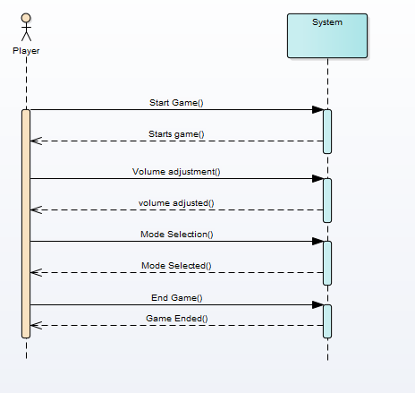

Figure 2‑2 Main Menu SDD

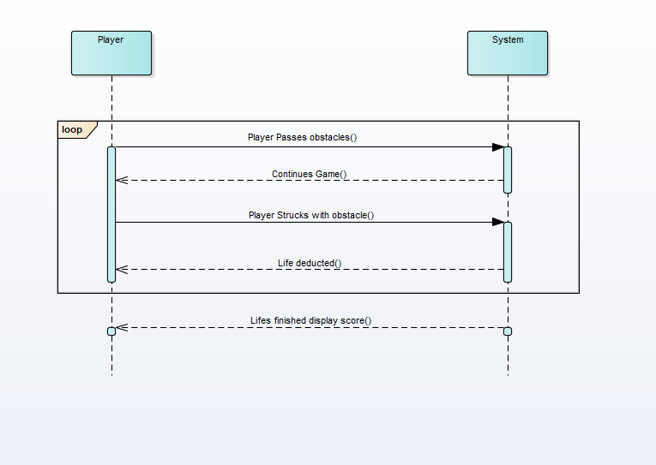

Figure 2‑3 Obstacles SDD

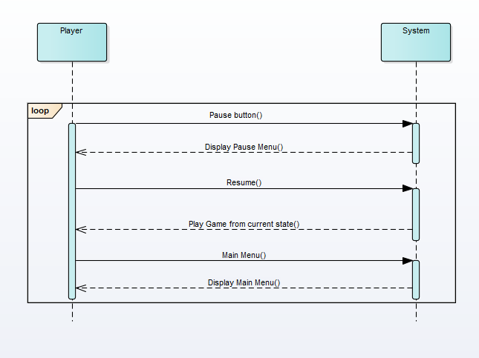

Figure 2‑4 Pause Menu SDD

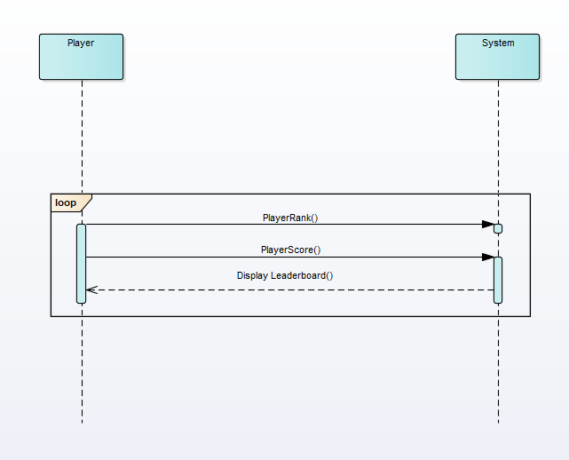

Figure 2‑5 Leaderboard SDD

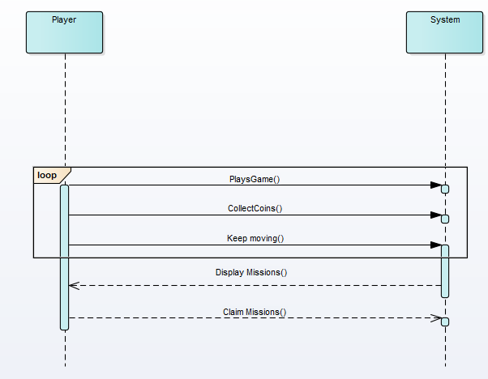

Figure 2‑6 Missions SDD

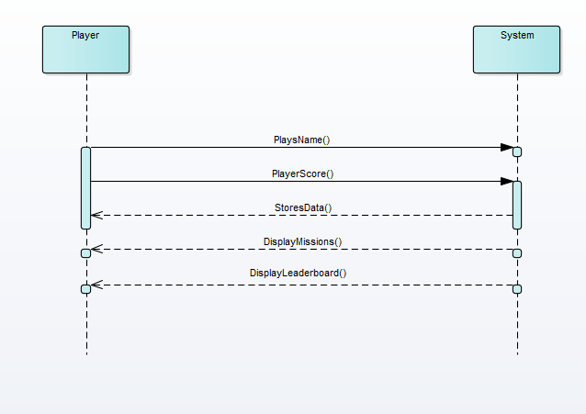

Figure 2‑7 Player Data SDD

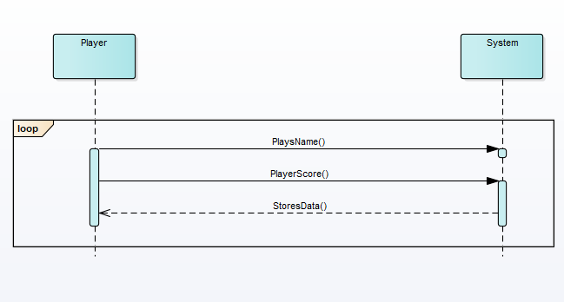

Figure 2‑8 Score SDD

## Domain Model

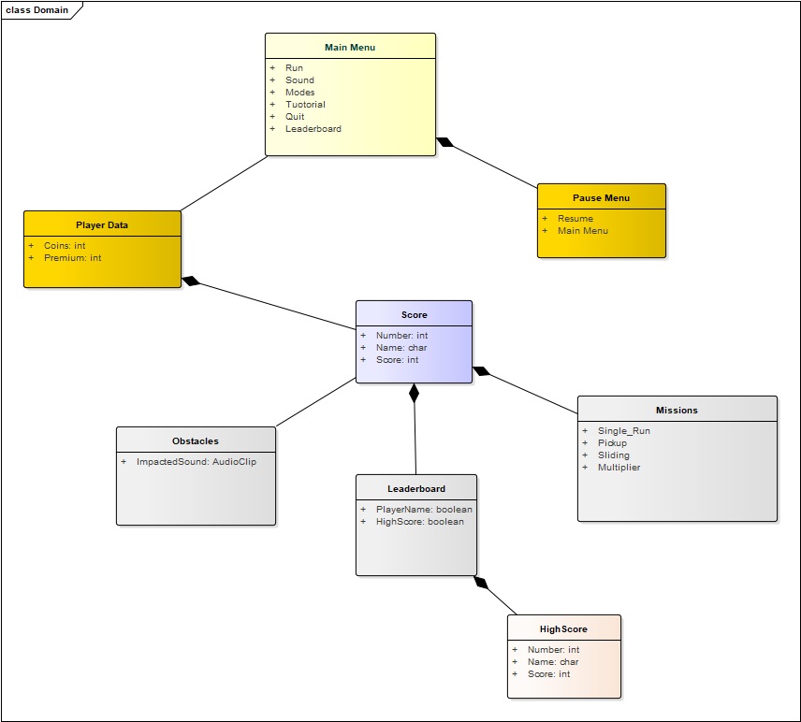

Figure 2‑9 Athlete Leader Domain Model

## Minimum Requirement

* **OS:** Windows xp 2007 and greater version.
* **Processor:** Core 2 duo or gretear processor
* **Memory:** 78 MB of ROM
* **Graphics:** Game doesnot requires any specific graphics for it.

## Limitation and Constraint

* This game doesnot requires any specific controller to play.
* Game is easy to install on any windows device.
* Game doesnot requires any internet after internet.

## User Interface Design (Prototypes)

User Interface (UI) Design focuses on anticipating what users might need to do and ensuring that the interface has elements that are easy to access, understand, and use to facilitate those actions. UI brings together concepts from interaction design, visual design, and information architecture.

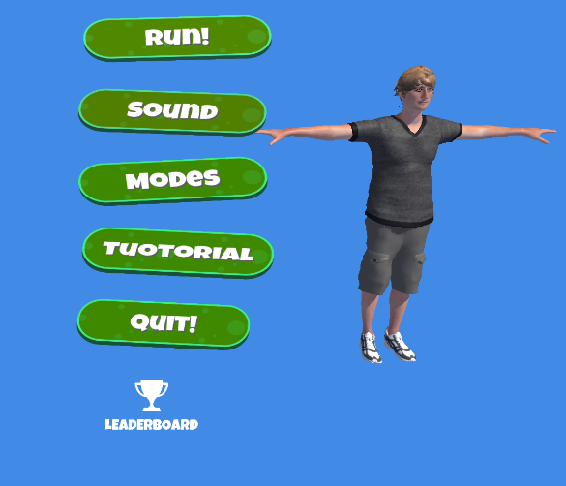

Figure 2‑10 Main Menu

A user will login to the game player will be able to choose any desired module such as can choose mode of his own choice and adjust volume accordingly, see tutorial and can quit any time he want to close game, Sound can be adjusted according user choice.

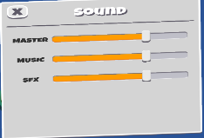

Figure 2‑11 Sound Menu

User will have scroll volume button through which it can be adjusted according to user.

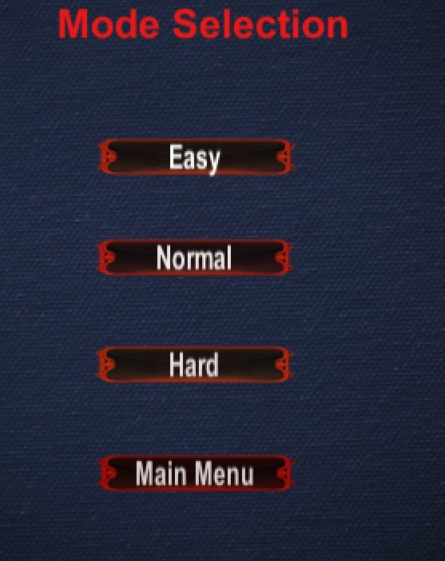

Figure 2‑12 Mode Selection

There will be four buttons in this menu through user can choose any of desired difficulty and also back button if player wants to go back to main menu.

**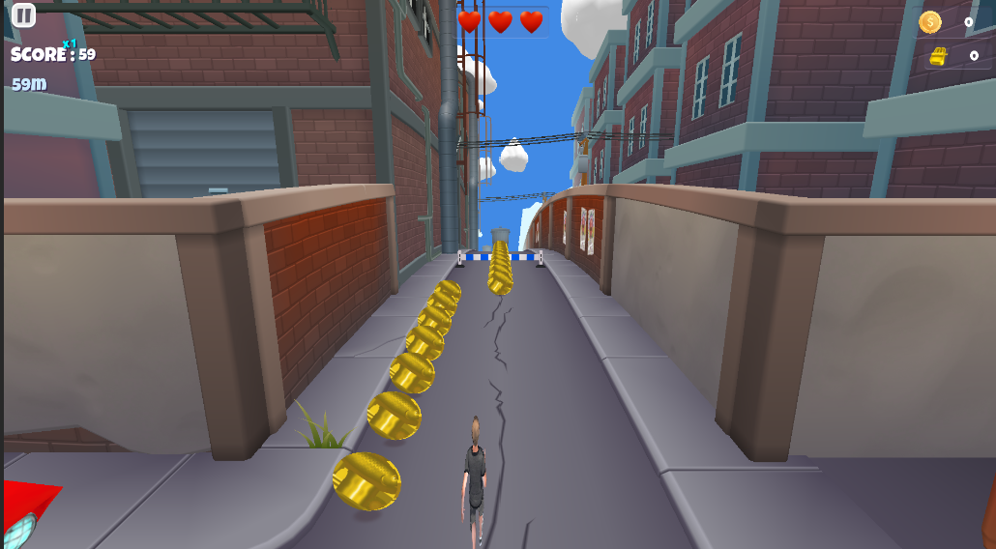**

Figure 2‑13 Gameplay

This will start game and time will be started and player will start running so player has to pass requirements to reach next level, there will be also pause button on top if user wants to stop game at any moment.

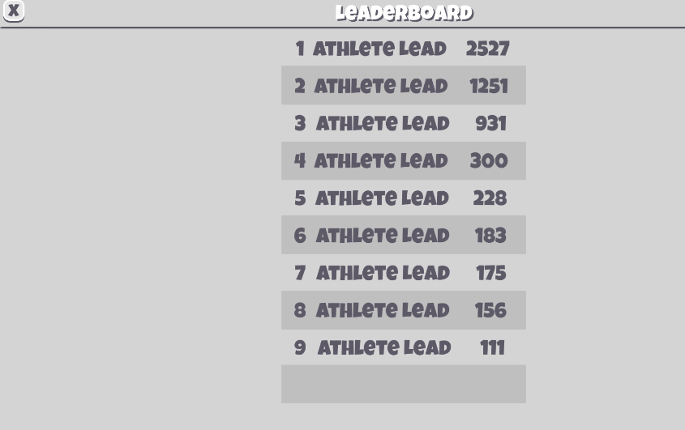

Figure 2‑14 Leaderboard

This will be displayed at the end of game having name, rank, and score of the player at the end of the game.

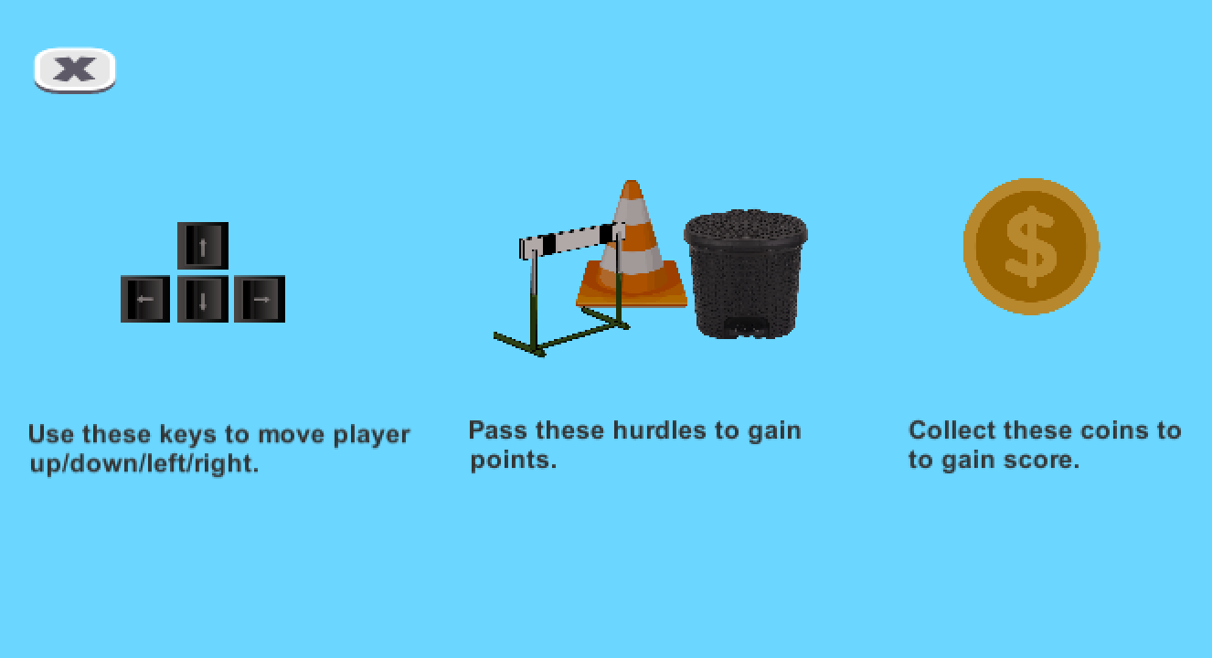

Figure 2‑15 Tuotorial

Tutorial interface will show that how user can play game how he can move to next level having arrows representation that are used to play game, Hpictures and descriptions and coins pictures and there description and there will also be main menu button through which user can move to main menu interface.

# Chapter 3

# System Design

## Software Architecture

Software architecture is described as the organization or structure of a system, where the system represents a collection of components that accomplish a specific function or set of functions.

**Presentation Layer:**

Occupies the top level and displays information related to services available on a website. This tier communicates with other tiers by sending results to the browser and other tiers in the network.

**Business Logic Layer:**

Application Layer also called the middle tier, logic tier, business logic or logic tier, this tier is pulled from the presentation tier. It controls application functionality by performing detailed processing.

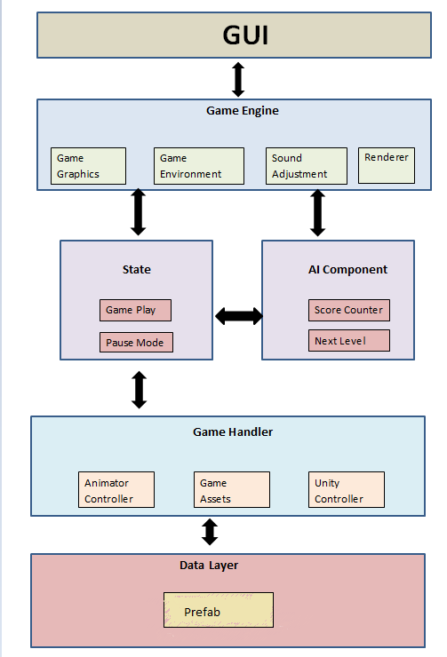

Figure 3‑1 Software Architecture Diagram

## Class Diagram

The class diagram describes the attributes and operations of a class and the constraints imposed on the system. The class diagrams are widely used in the modeling of object-oriented systems because they are the only UML diagrams, which can .be mapped directly with object-oriented languages.

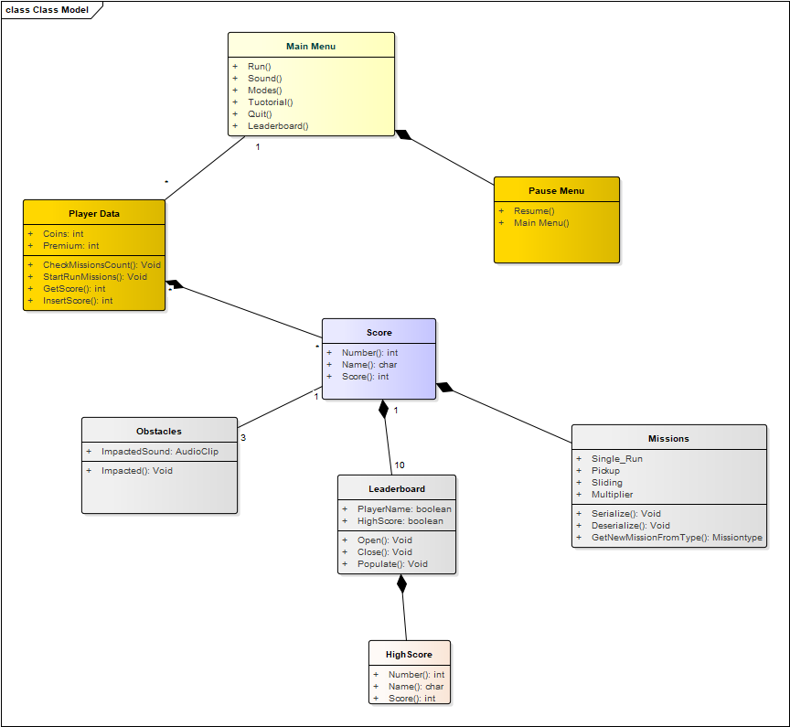

Figure 3‑2 Class Diagram

## Sequence Diagram

Sequence Diagram model the flow of logic within your system in a visual manner enabling you both to document and validate your logic, and are commonly used for both analysis and design purposes

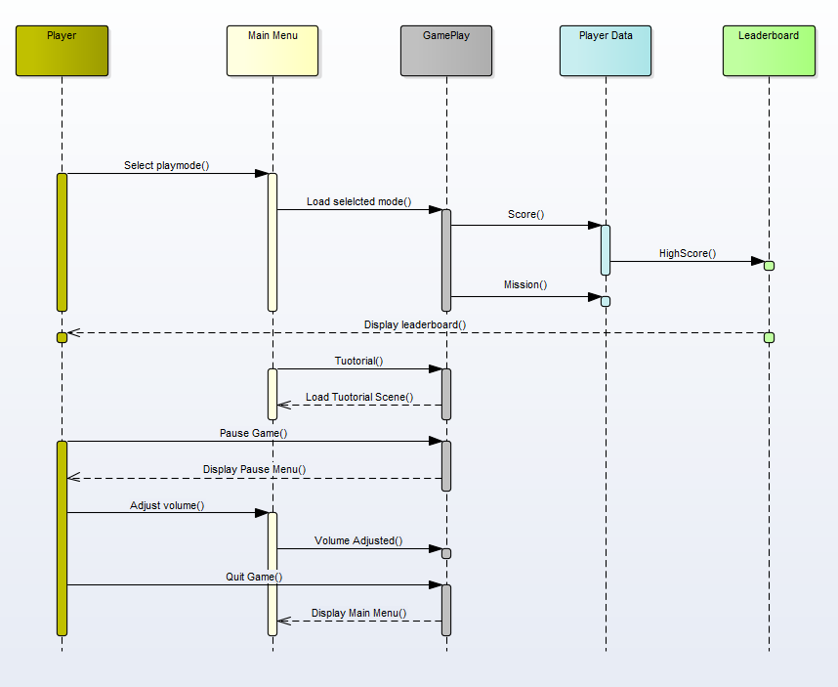

Figure 3‑3 Sequence Diagram

## Entity Relationship Diagram

The entity-relationship model (or ER model) is a way of graphically representing the logical relationships of entities (or objects) in order to create a database. An entity– relationship model (ER model) describes inter-related things of interest in a specific domain of knowledge. An ER model is composed of entity types (which classify the things of interest) and specifies relationships that can exist between instances of those entity types.

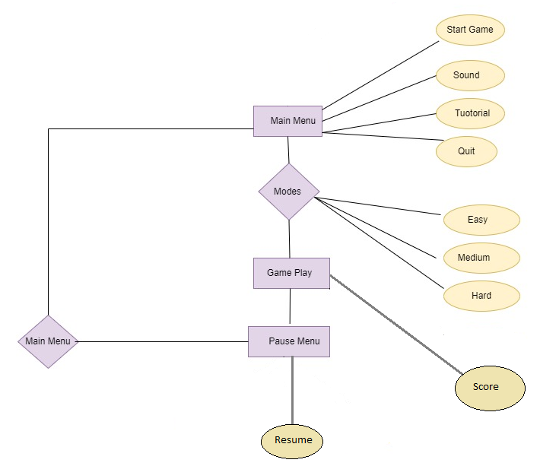

Figure 3‑4 Entity Relationship Diagram

## Gameplay Diagram

This gameplay diagram is a simple flow chart of how to play the game, it will also show how many levels are there with what complexity of game play including players, objects which is shown in Figure

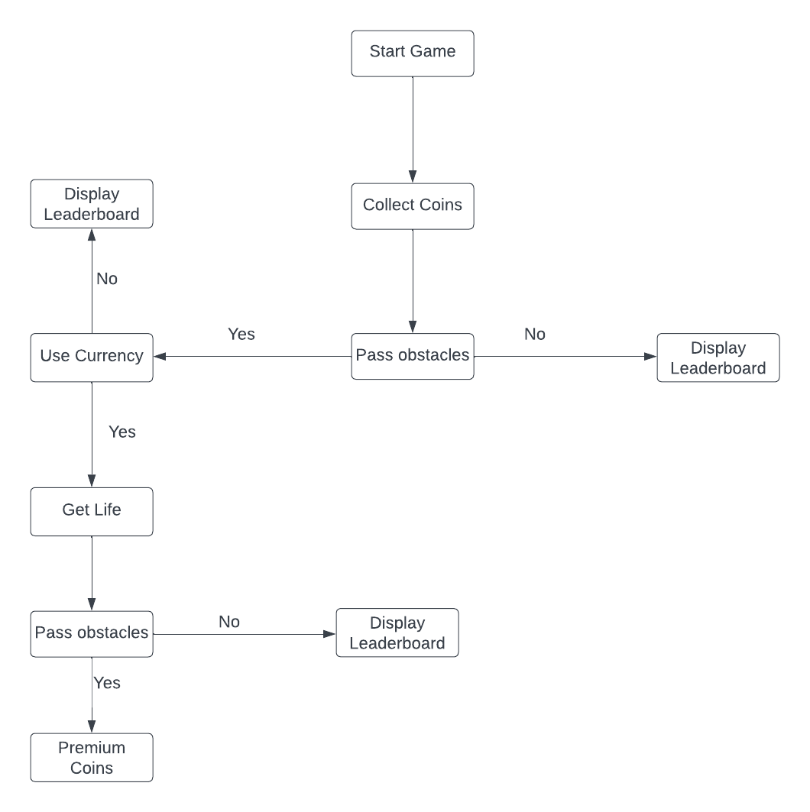

Figure 3‑5 Gameplay diagram



# Chapter 4

# Software Development

This chapter will provide the details about the coding standard, we adopted during implementation phase.

## Coding Standards

The adopted coding standards are discussed in the following subsections.

**4.1.1. Indentation**

Four spaces are used as the unit of indentation. The indentation pattern should be consistently followed throughout.

**4.1.2. Declaration**

* First of all the variables are initialized as a sequence in start of every script.
* Public and Private function instances are used in code according to their need and their importance.
* After declaring variables constructors are used after that.
* After declaring constructors functions are declared.
* Proper try catch or exception throwing functions used to deal with errors or bugs.

**4.1.3. Comments**

Proper commenting are used for each of function and class to make code understandable and readable by new programmers or anyone who wants to read code can easily understand the code logic by reading these comment lines.

**4.1.4. Naming Convention**

Naming conventions make programs more understandable by making them easier to read. Following conventions are followed while naming a class or a member:

We used full English descriptors that accurately describe the variable, method or class. For example use of leaderboard, missions, obstacles etc. are used in functions to be understandable by everyone.

Capitalized first letter and then lower case letters are used to make code easy to read for every class and function.

## Development Environment

Unity is a cross platform game engine developed by Unity Technologies first announced and released in June 2005, at Apple Developers conference. The engine has since been gradually extended to support variety of desktop, mobile, console and virtual reality platforms. It is generally used for ios and android game development and easy to use for beginner’s developers.

The reason for using this platform is that it is easy to use and easily understandable as it has specific modes and console for scene and game development mode. Its interface is user friendly and provides guidelines for every specific object and instance that how to use that function so that is very handy for the beginner to gain some knowledge or experience about game development. Alternatives of Unity are Unreal Engine, Godot Engine and Game Maker Engine these tools are somehow expensive for new developers and are mostly used for high level graphics game making.

## Software Description

Main modules of our project are

* Player Data Module.
* Leaderboard Module.
* Game over Module.
* Missions Module.

### Player Data Module

**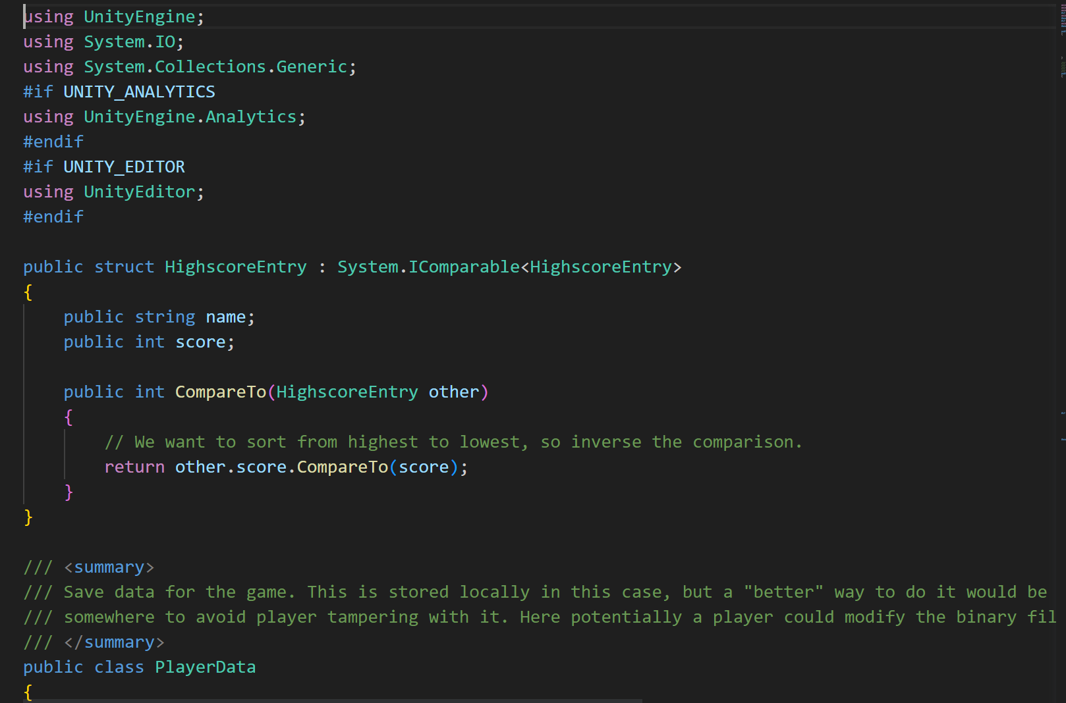**

**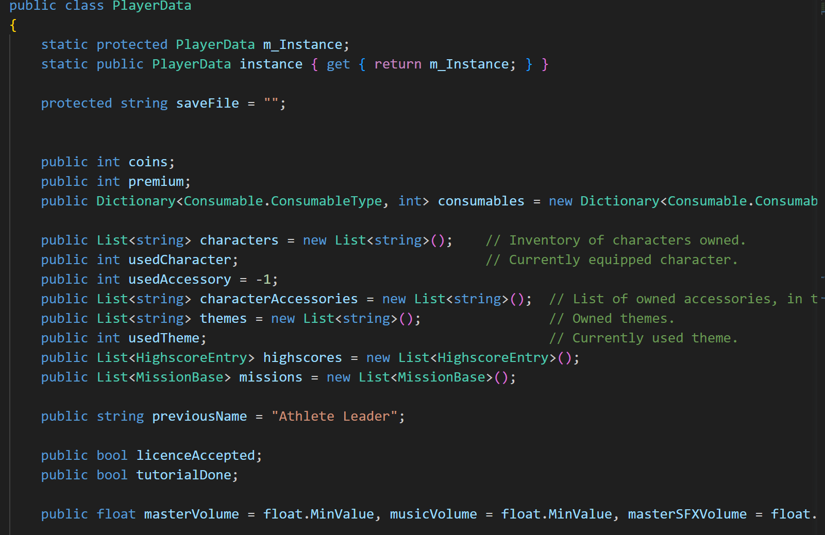**

**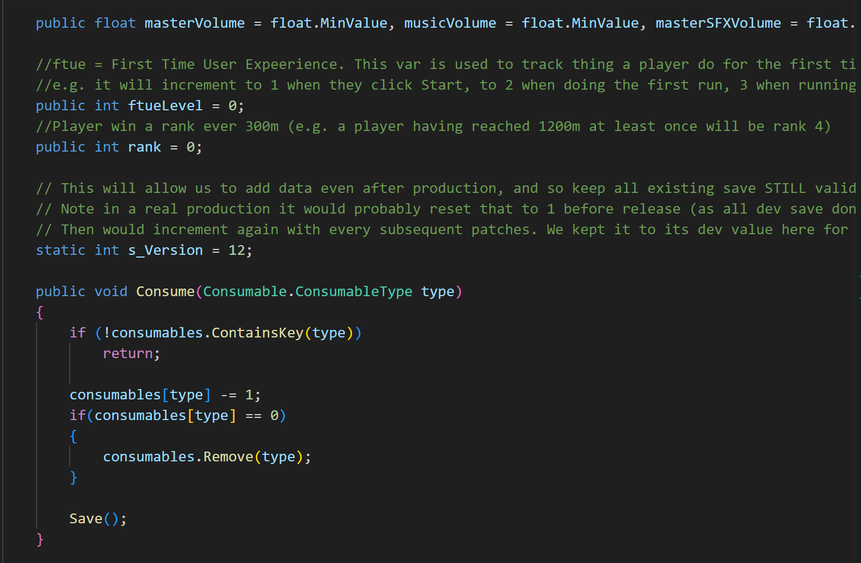**

**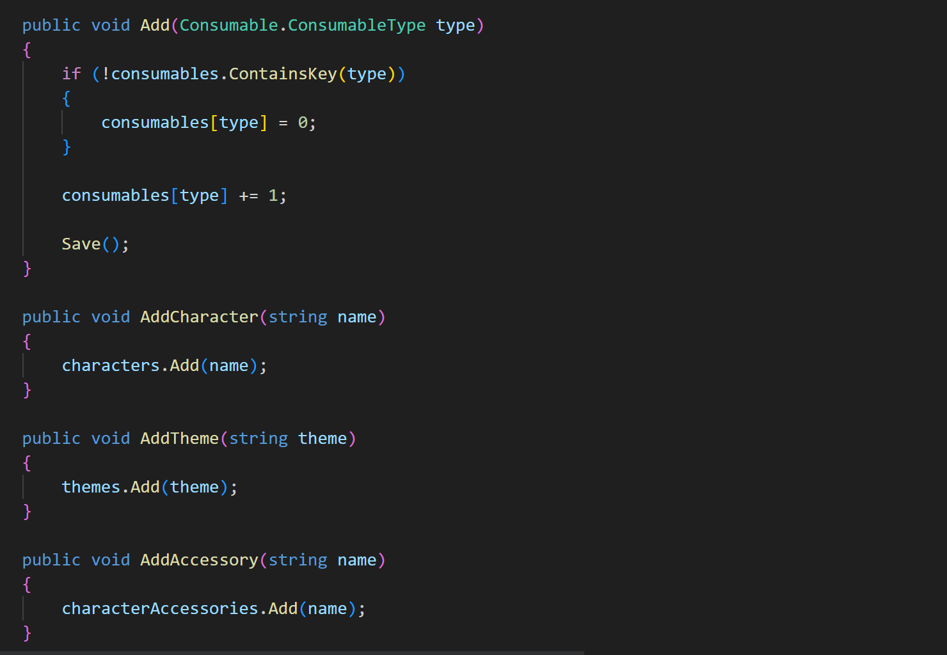**

**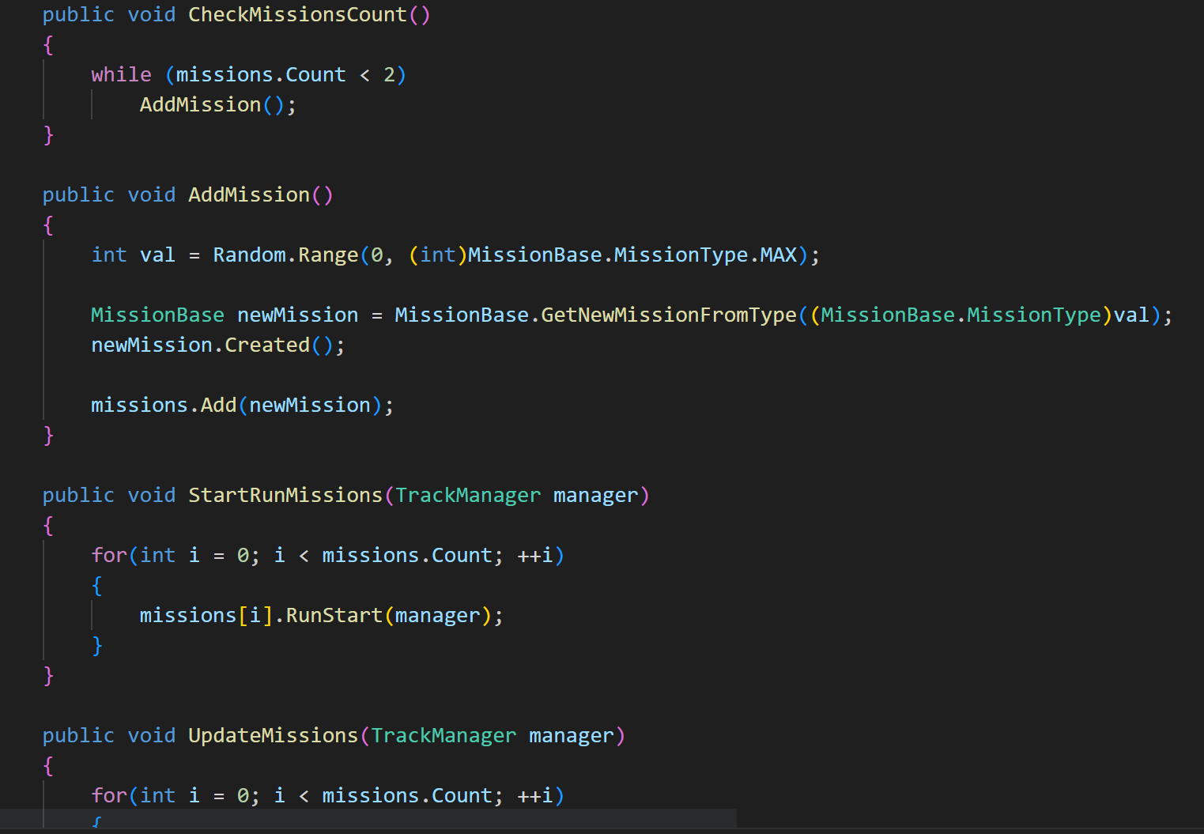**

**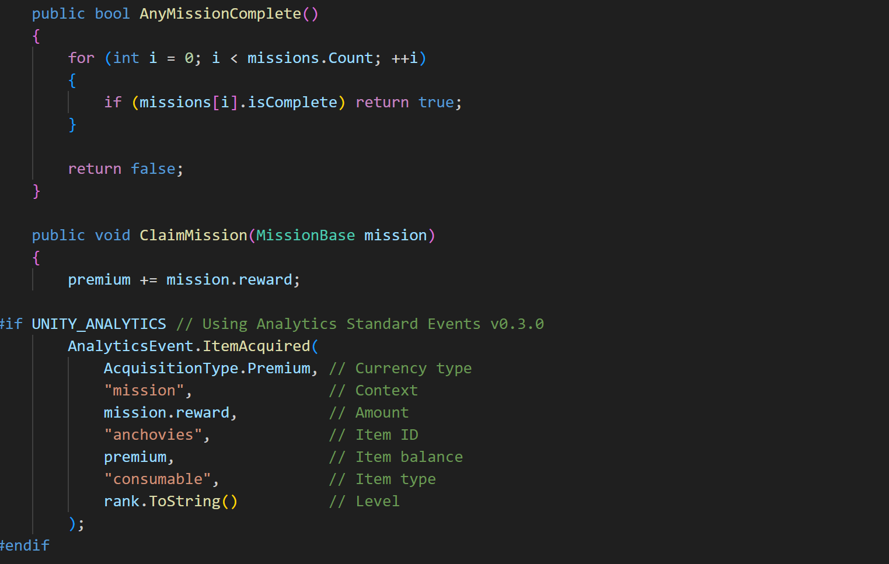**

**Description**: This Module stores the information of the players in a prefab and stores data of a player once a player plays a game.

If player plays game again its data will be saved and missions will be displayed at end of game and its rank by comparing with others will be displayed. This module store player name and score in it in a prefab.

### Leaderboard Module

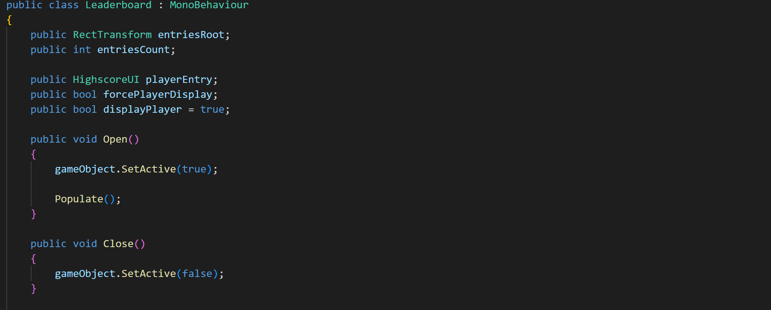

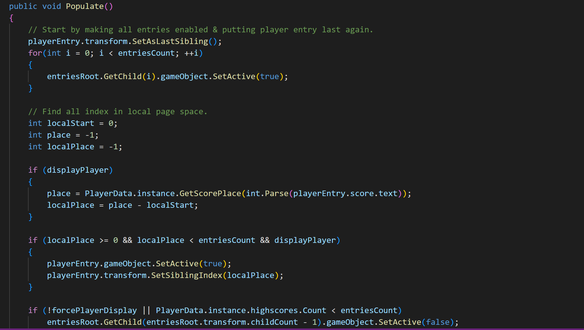

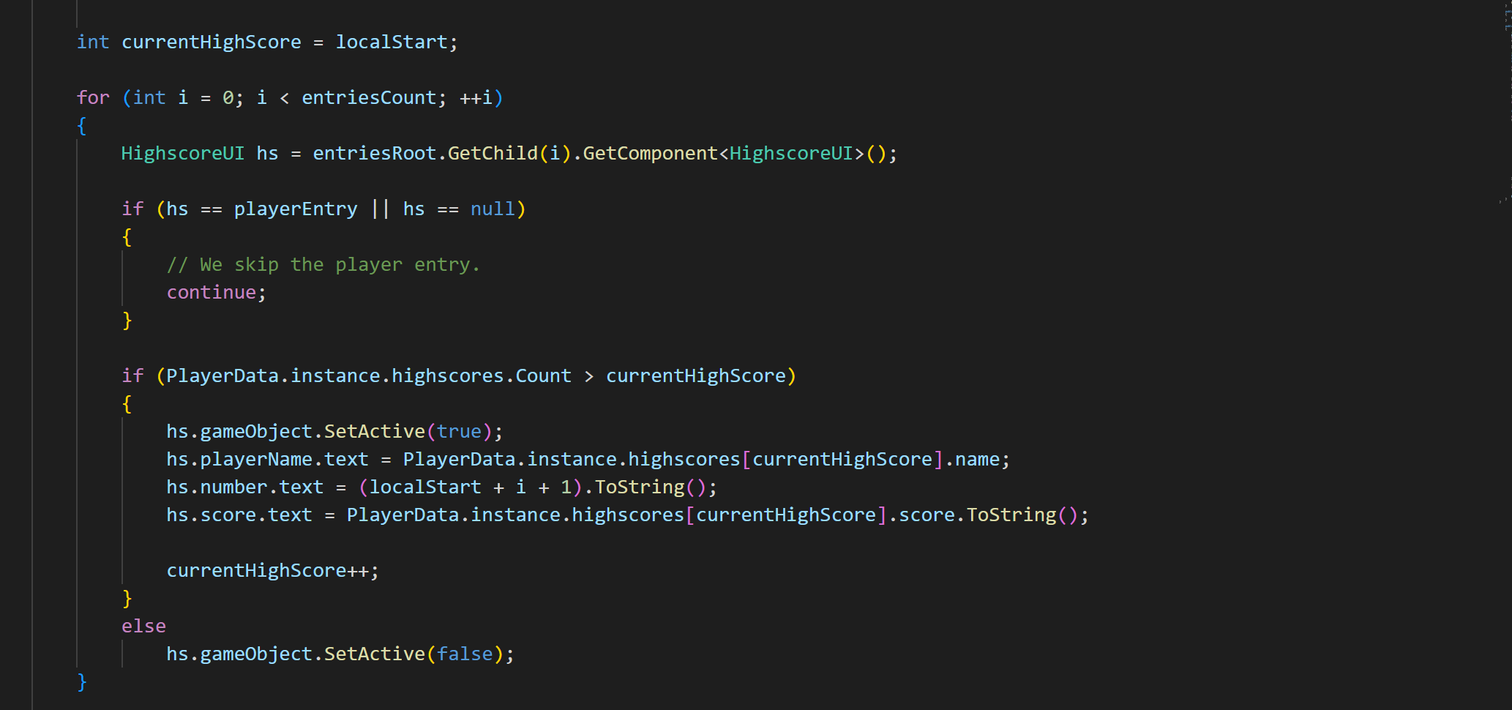

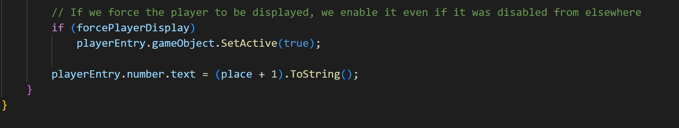

**Description:** This module gets the data from the game play manager and updates the leaderboard at the end of the game these scores are being displayed to the leaderboard.

This module also ranks the player number or rank according to its score and a player can edit its name at any time after ending game by clicking on text field displayed on the leaderboard. This module also checks whether game is completed or not such that if user pause the game and quit the game its data will not be saved in the leaderboard.

### GameOver Module

**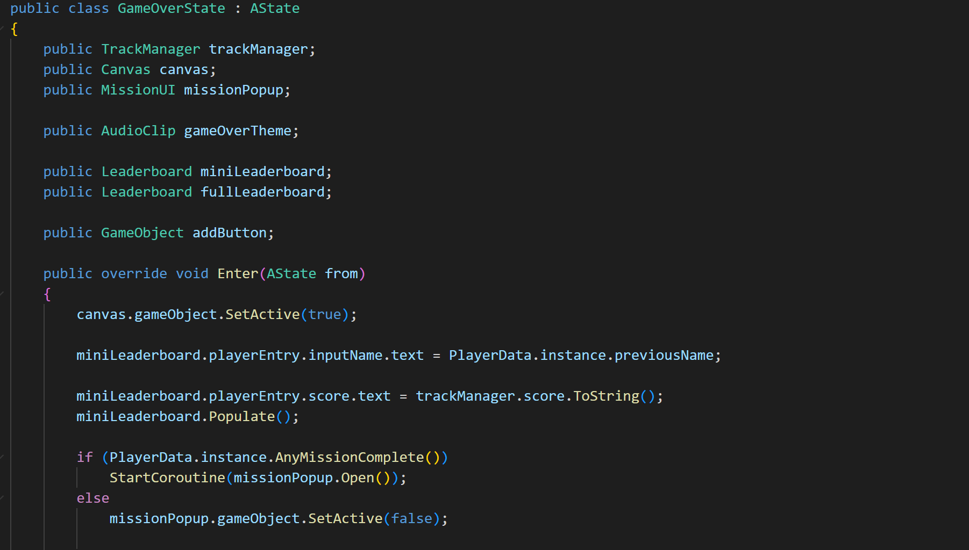**

**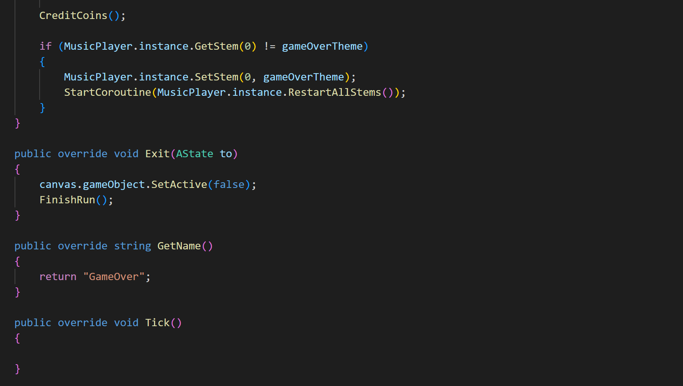**

**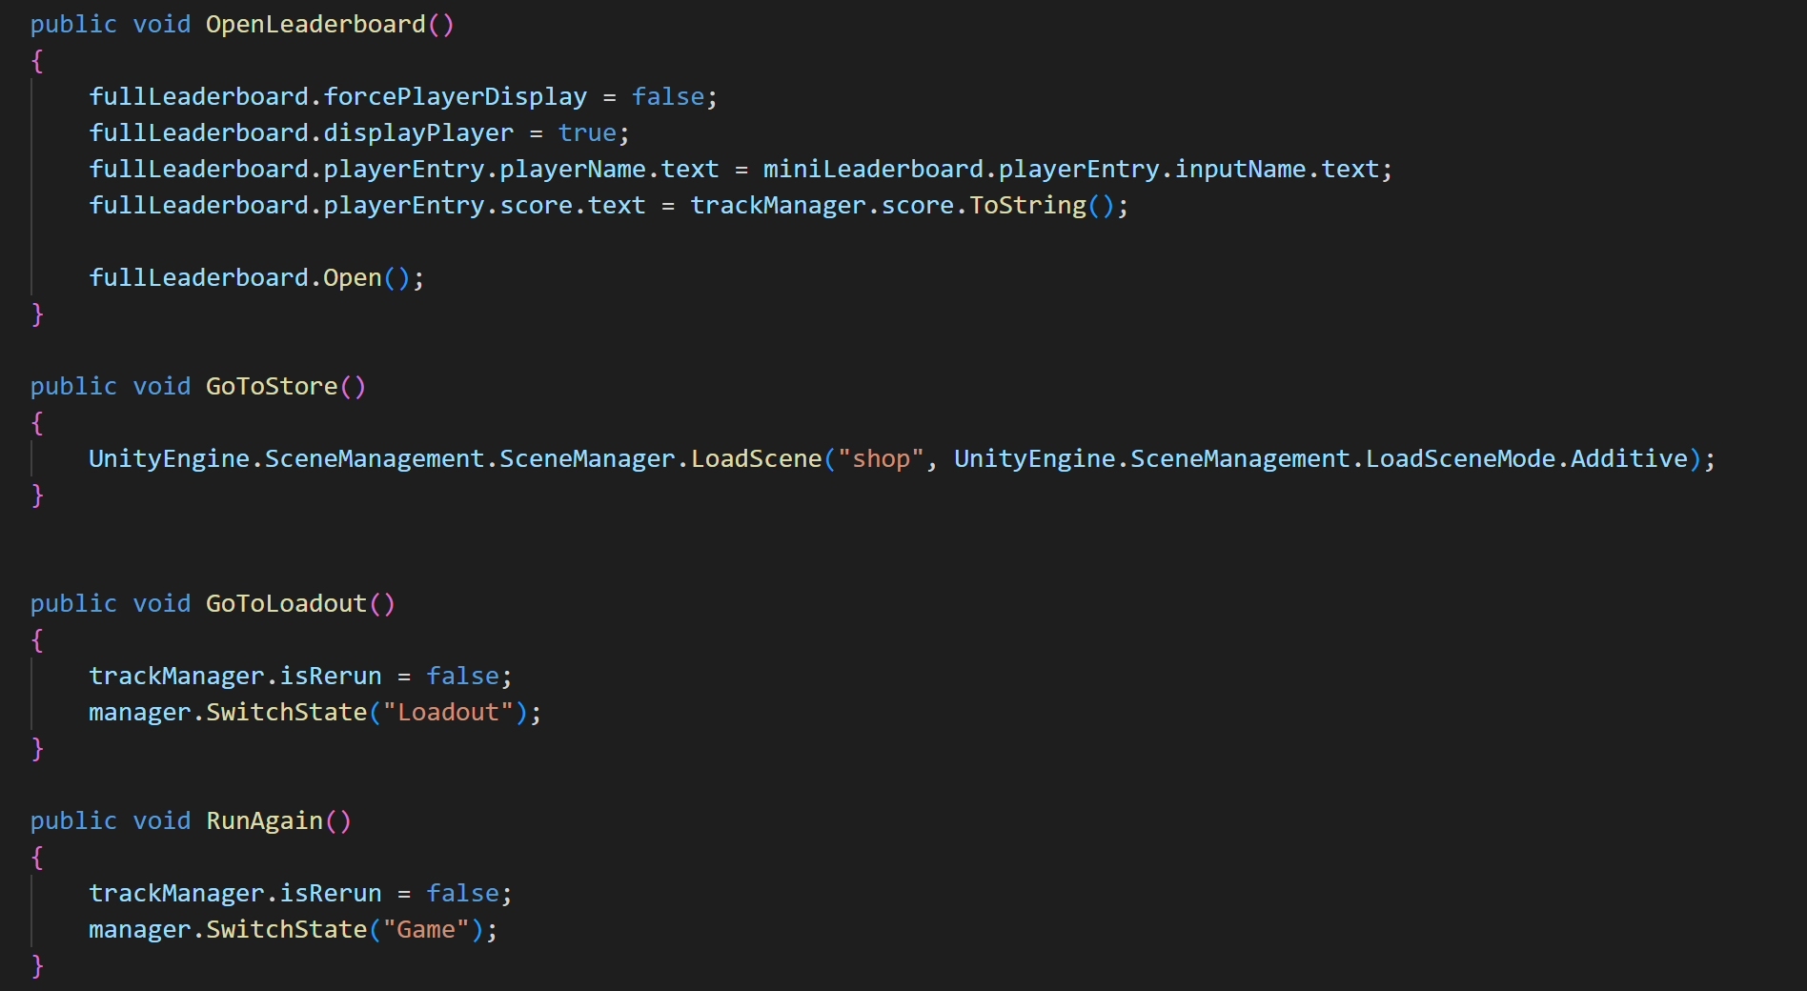**

**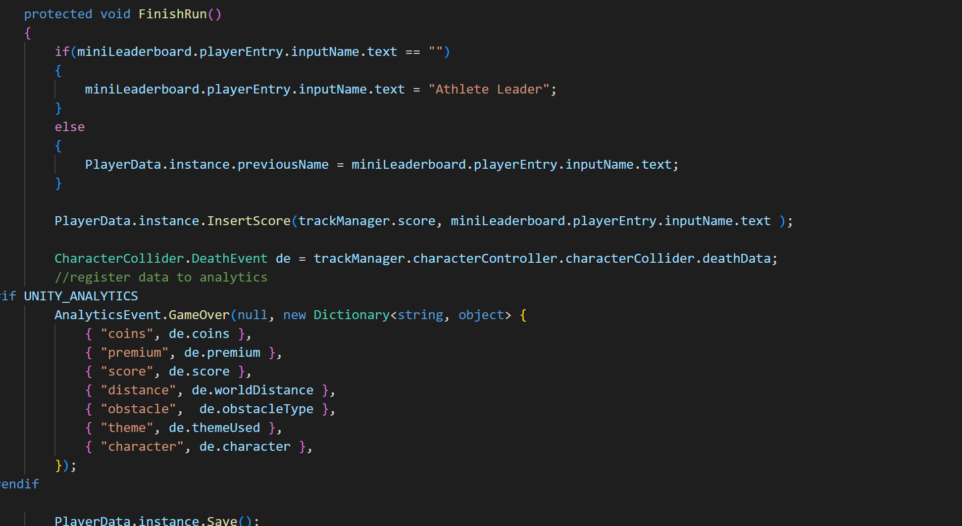**

**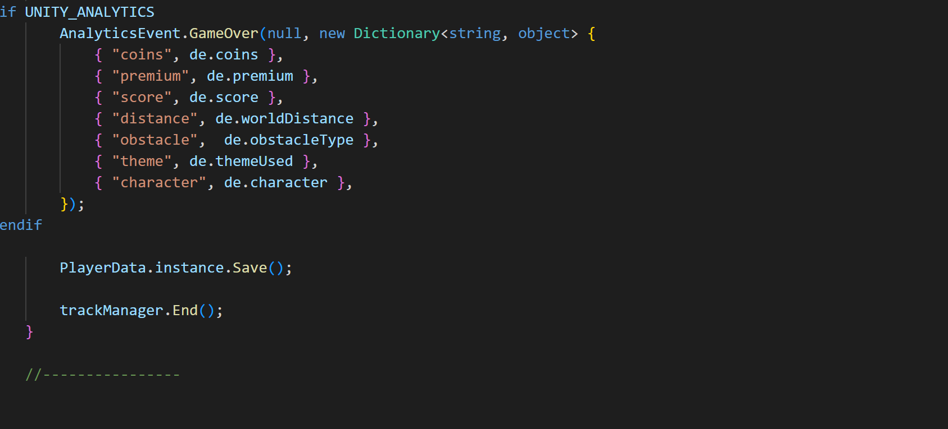**

**Description:** This module is loaded when a game gets over or life of player becomes equal to zero than this pop up menu will be appeared in front of screen.

This module allow player to edit his name and also will allow user to run or continue game using special coin or premium options to reload the game from run again button that will be displayed using this module this also allows player to return to main menu after if he is not willing to continue game he can quit game at any time. A popup menu of missions completed will also be displayed using same module if user has achieved any mission.

### Missions Module

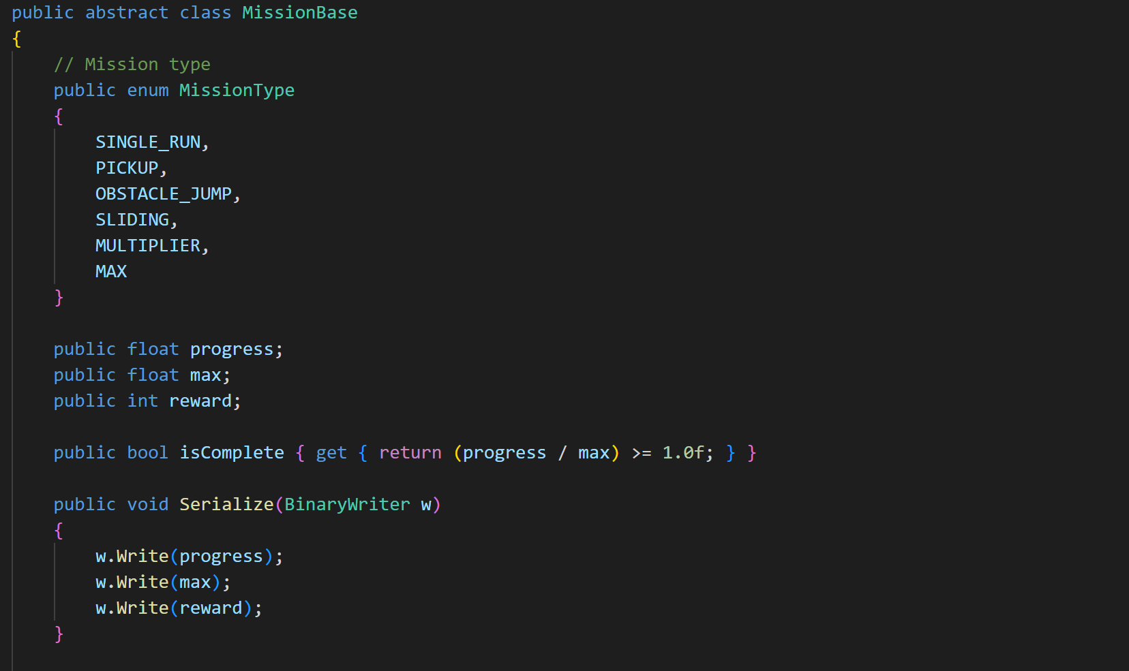

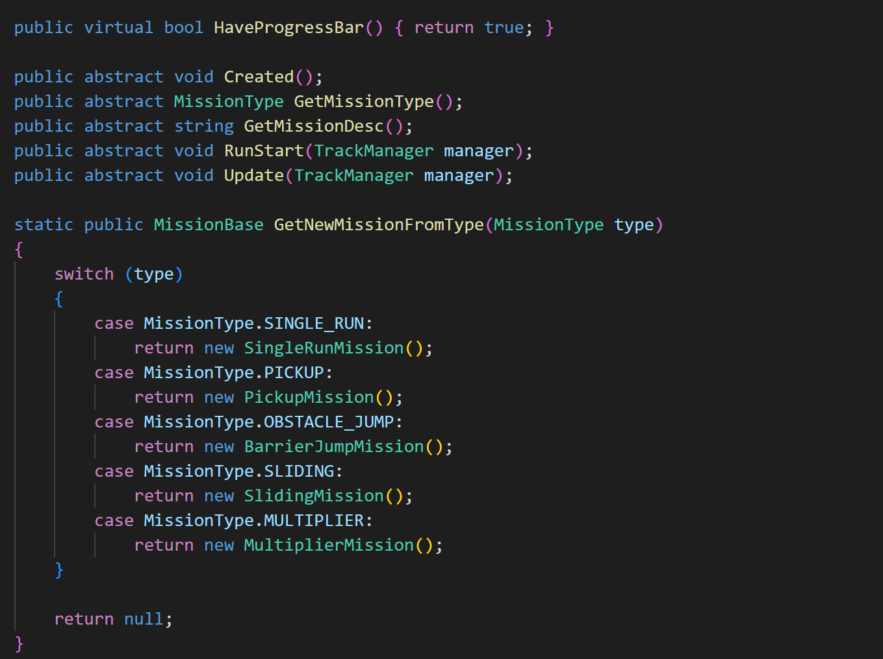

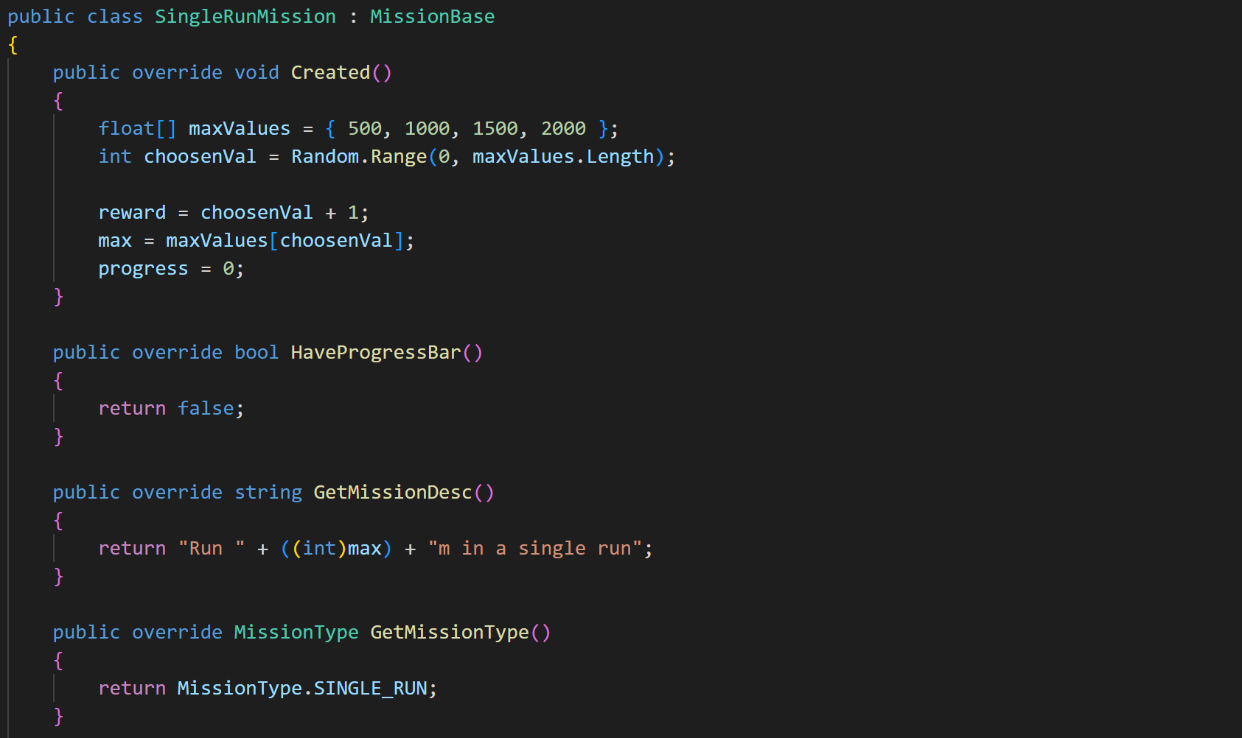

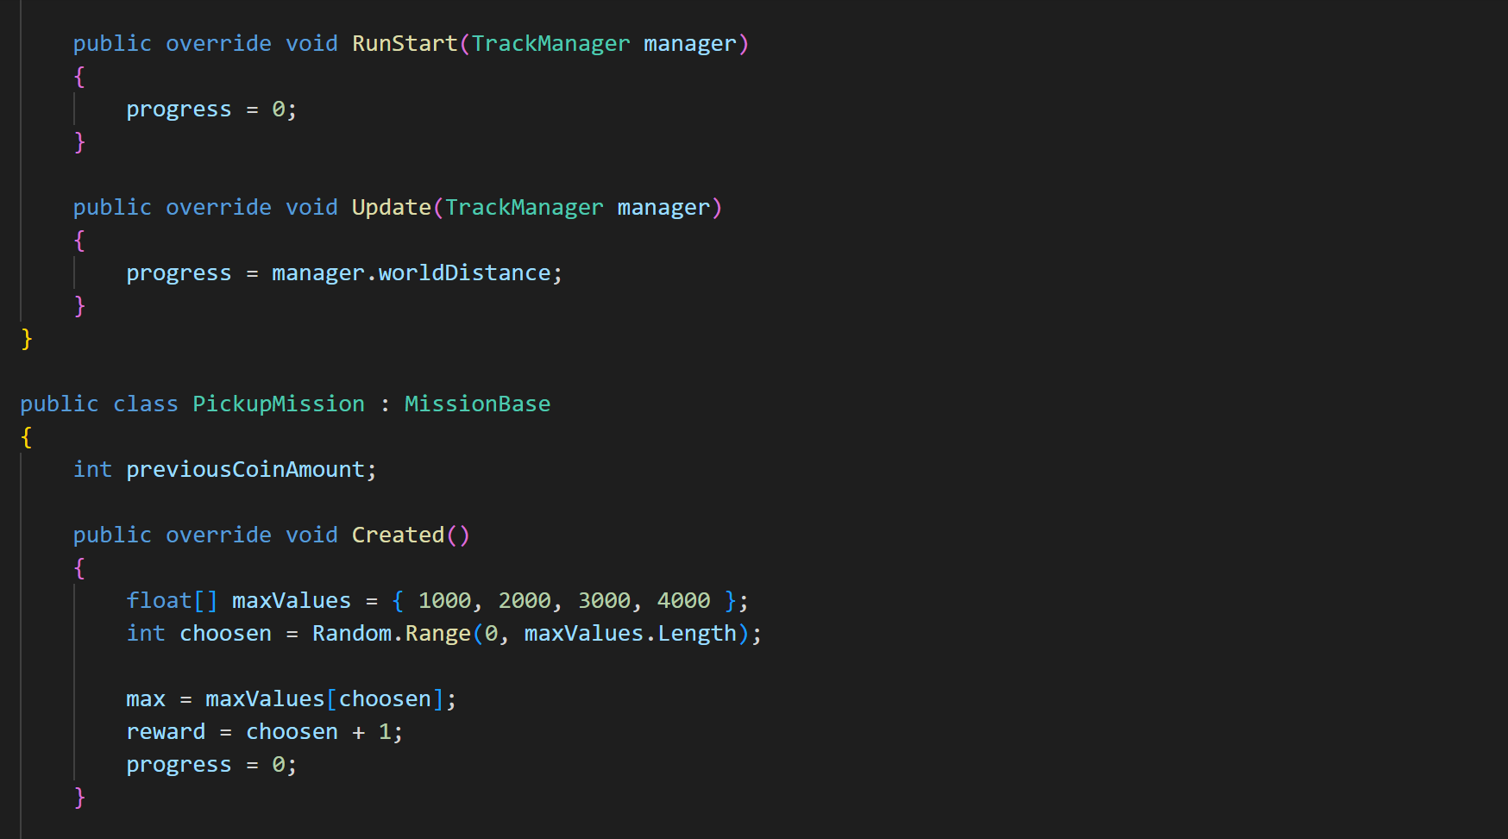

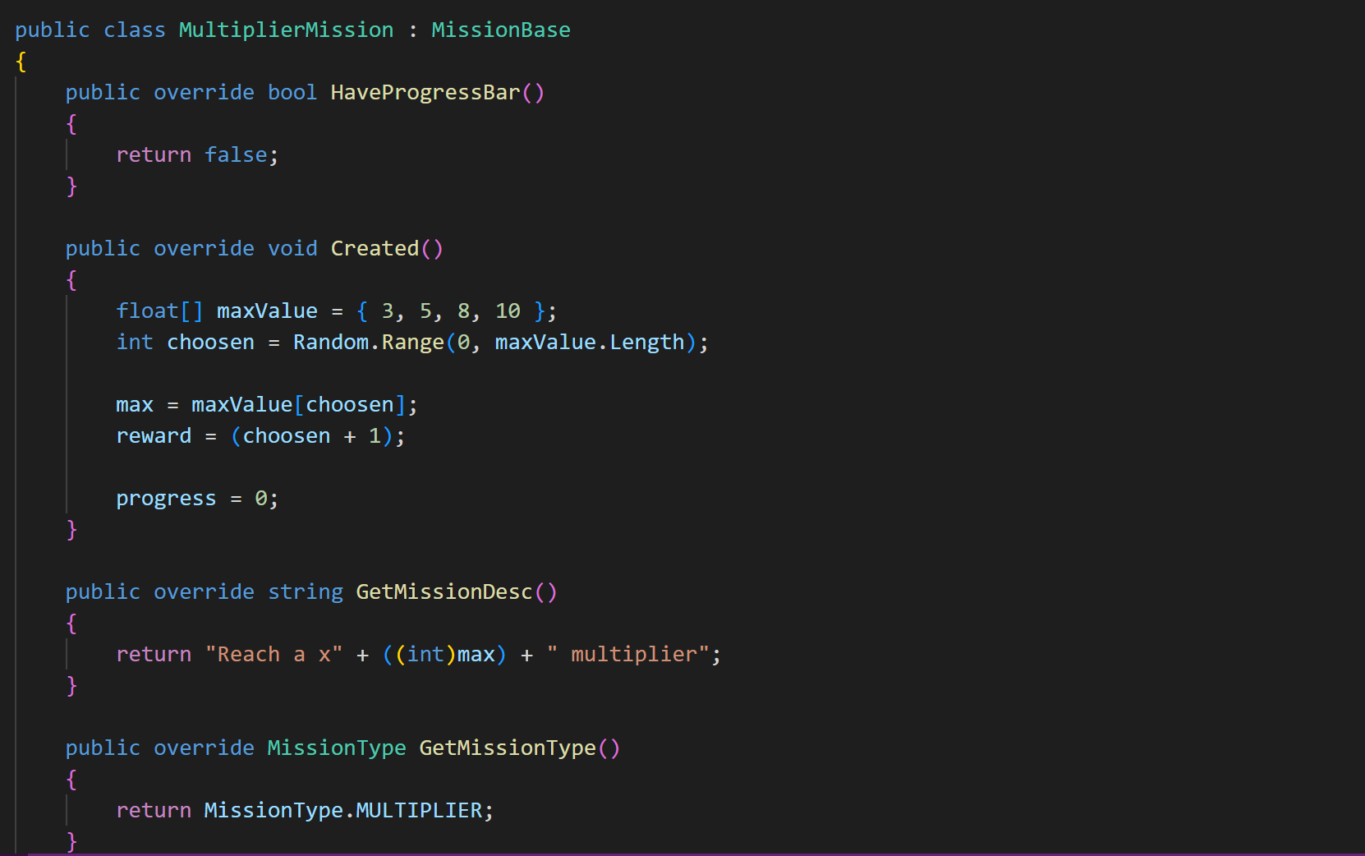

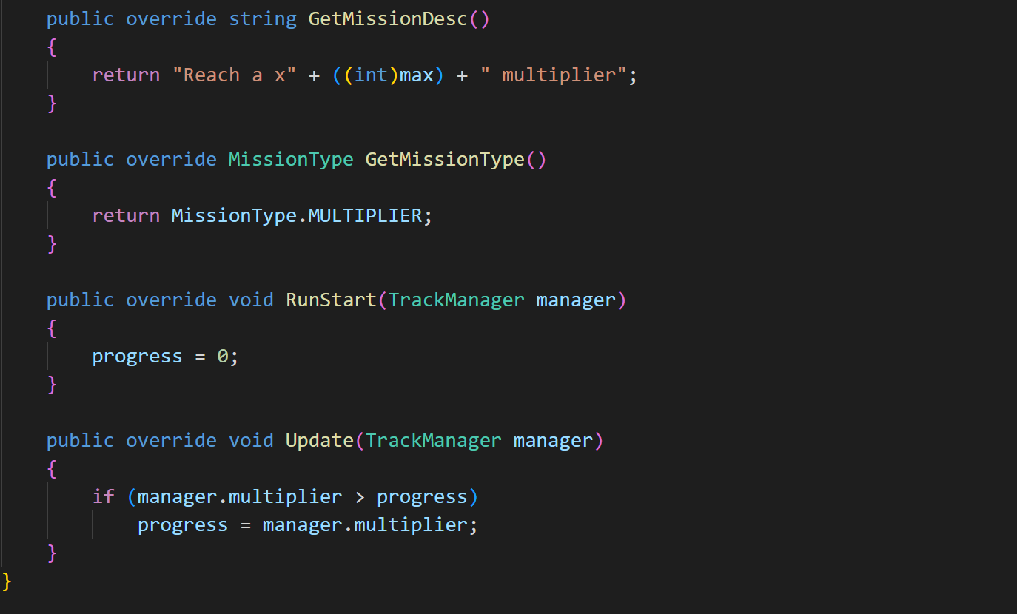

**Description:** This module is loaded when pause menu is loaded and also when game is ended and if player has achieved a specific milestone than this module is displayed on screen.

This module gathers data from game manager and display the updated mission module if player has achieved any of the reward he can collect this reward from the mission and this reward will be added to the player profile and player can use this reward later in game. After player collect this reward mission module gets updated and new mission is loaded in the game.

## 3D/2D Objects, Terrain, & Scene Management (For Games based FYP)

We are using following main objects in our game.

**Character**

**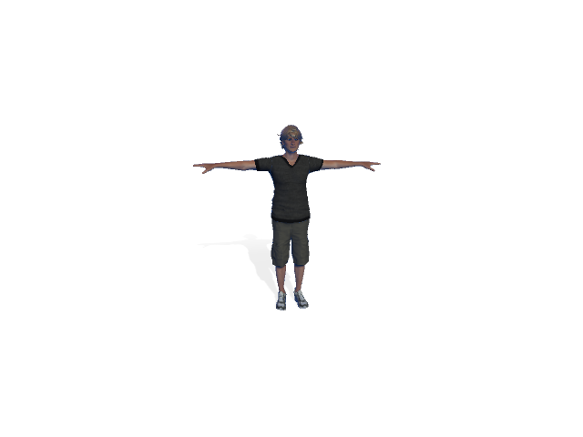**

Figure 4‑1 Character Model

All of the game is based on this character all of the animations are working almost this character and controlling the effect of its motion with effect to the environment.

**Obstacles:**

**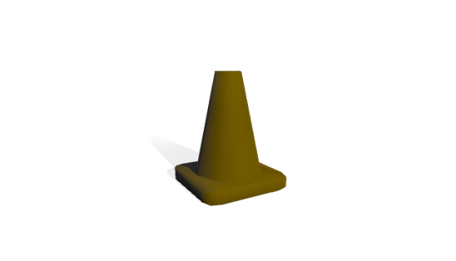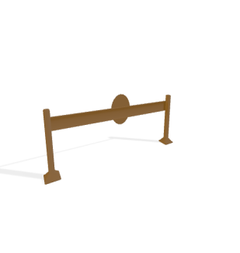**

Figure 4‑2 Obstacles Model

There are many obstacles included in the path of player to make its journey difficult and more difficult as time passes these are the few obstacles as listed above that are used in the game for make journey of player difficult.

**Scenes:**

Following scenes are used in game.

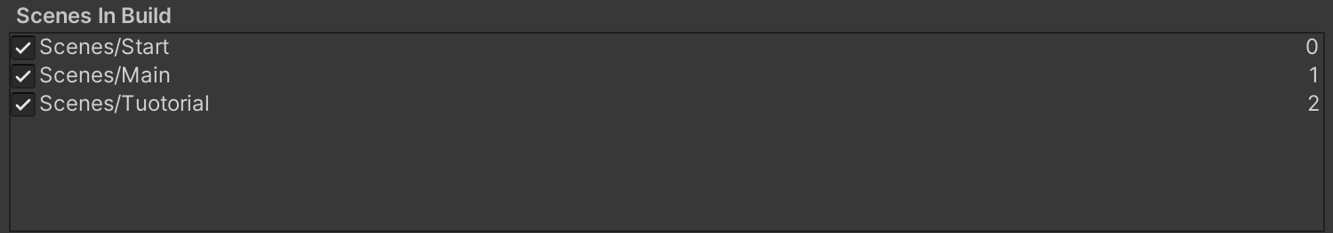

Figure 4‑3 Scenes

**Main Scene:**



Figure 4‑4 Main Scene

This scene allow player to run game and adjust sound according to need of user and also can select any mode of his choice and if he is playing first time or new user he can use tutorial scene button and if he doesn’t want to continue game he can quit game at any moment. Player can also choose shop and leaderboard button.

**Tutorial Scene:**



Figure 4‑5 Tuotorial Scene

This scene allows user to know how to play game if he is new user or has no idea about that how he should play game he can use tutorial option and can get guidelines of playing game from that scene.

## Software Minimum Requirement

* **OS:** Windows xp 2007 and greater version.
* **Processor:** Core 2 duo or gretear processor
* **Memory:** 78 MB of RAM
* **Graphics:** Game doesnot requires any specific graphics for it.

## Software Limitations and Constraint

* This game doesnot requires any specific controller to play.
* Game is easy to install on any windows device.
* Game doesnot requires any internet after internet.

## General Assets

**Premium Coins:**

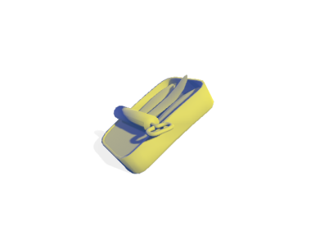

Figure 4‑6 Premium Coins

These are used to give player additional power if a player collides with them he will get more power and will create easiness for player to gain more score and move on.

**Environment assets:**

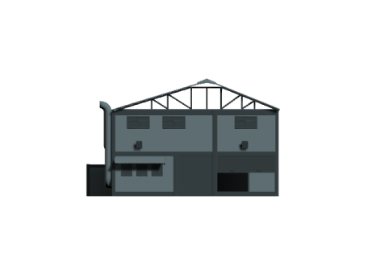

Figure 4‑7 Environment Assets

We have used too many assets like apartments and cars or lines as we cannot mention them all but above is the some of the assets used in environment like houses and trees are most occurring assets in environment that will be multiplied along with the movement of the player.

**Hurdles:**



Figure 4‑8 Hurdles

There are many hurdles included in the path of player to make its journey difficult and more difficult as time passes these are the few hurdles as listed above that are used in the game for make journey of player difficult.

## 4.7 Online Market Store

This game has be submitted on the [itch.io](https://itch.io) and is accessible easily and free to any user or public.

* Game requires account on that wrbsite by user.
* Game files are available in zip folder and can eaily run on any pc or windows device

# 

# Chapter 5

# Software Testing

Software Testing is the most crucial part of Software Development Process. It is the investigation or evaluation of a software component, improving them, and finding bugs and defects. Testing is usually done by executing a system in such a way that it identifies any gaps, errors, or missing requirements in contrary to the actual requirements.

## Testing Methodology

We have used black box testing in our testing phase. We used black box testing because it is very efficient and it contains following benefits. Black box testing is a method of software testing that examines the functionality of an application without peering into its internal structures or workings. This method of test can be applied virtually to every level of software testing: unit, integration, system and acceptance. Black box unit testing is used in our project.

Unit testing is process of software testing method in which we test each of the single modules in the system in the game testing each of single modules or function of game is tested by various playing modes and methods.

* Black Box testing helps to find bugs easily.
* Helps to test each module easily.
* Bug and error can be restored.
* Tester needs no specifc knowledge about system specifically programming knowledge.

## Testing Environment

**Unity 3d**

Unity 3d is a game editor having multiple functionalities including its store and animator and packages of its own

We have use this tool by conducting multiple unit test by checking each and every functionality of game by using this tool as this tool is easy to use and easily understandable by new user provide guidelines for each and every single module. This tool is easy for beginners to learn and easily implementable.

## Test Cases

### Test Case 1

Table 5‑1 Test Case Main Menu

|  |  |
| --- | --- |
| Date: 20 March 2023 |  |
| *System:* Menu Drive |  |
| *Objective:* Display Main Menu of game | *Test ID:*1 |
| *Version:*1 | *Test Type:* Functional testing |
| *Input:*  Load the exe or apk file of game. | |
| *Expected Result:* Display Main Menu of game. | |
| *Actual Result:* passed | |

**Description:**

This test case is performed on unity 3d in editor mode while playing game we have loaded unity project and tested each of module of the main menu and its every function was working according to its requirement.

This test case was performed by all of the members of the group and main menu was loaded successfully on the screen and was fully functional.

### Test Case 2

Table 5‑2 Test Case Mode Selection

|  |  |
| --- | --- |
| Date: 20 March 2023 |  |
| *System:* Menu Drive |  |
| *Objective:* Load mode of game | *Test ID:*2 |
| *Version:*1 | *Test Type:* Functional testing |
| *Input:*  Load the Easy, Hard, and Normal Modes by clicking on them.  Select back button to return main menu. | |
| *Expected Result:* Load the selected mode. | |
| *Actual Result:* passed | |

**Description:**

This test case is performed on unity 3d in editor mode while playing game we have executed game and loaded mode selection and tested all of its three functions and back button functionality

This test case was performed by all of the members of the group and all of functions were working accurately and back button was also working according to its need.

### Test Case 3

Table 5‑3 Test Case Start Game

|  |  |
| --- | --- |
| Date: 20 March 2023 |  |
| *System:* Menu Drive |  |
| *Objective:* Starts the game | *Test ID:*3 |
| *Version:*1 | *Test Type:* Functional testing |
| *Input:*  Click on the Run button from main menu. | |
| *Expected Result:* Starts the game. | |
| *Actual Result:* passed | |

**Description:**

This test case is performed on unity 3d in editor mode while playing game we have executed game and run game by clicking on the run button in main menu this will load game in normal mode.

This test case was performed by all of the members of the group and all of functions was working accurately as all of environment was loaded perfectly and hurdles and coins was also working correctly.

### Test Case 4

Table 5‑4 Test Case End Game

|  |  |
| --- | --- |
| Date: 20 March 2023 |  |
| *System:* Menu Drive |  |
| *Objective:* Quit the game | *Test ID:*4 |
| *Version:*1 | *Test Type:* Functional testing |
| *Input:*  Select Quit button from main menu | |
| *Expected Result:* Closes the game. | |
| *Actual Result:* Passed | |

**Description:**

This test case is performed on unity 3d in editor mode while playing game we have executed game and in main menu we clicked the quit button but it was working perfectly.

This test case was performed by all of the members of the group and all of functions was working accurately as game was quit on being clicked on quit button.

### Test Case 5

Table 5‑5 Test Case Obstacles

|  |  |
| --- | --- |
| Date: 20 March 2023 |  |
| *System:* Menu Drive |  |
| *Objective:* Load obstacles. | *Test ID:*5 |
| *Version:*1 | *Test Type:* Functional testing |
| *Input:*  Load game and pass the obstacles in the way. | |
| *Expected Result:* Load new obstacles on passing hurdle and update score. | |
| *Actual Result:* passed | |

**Description:**

This test case is performed on unity 3d in editor mode while playing game we have executed game and run game by clicking on the run button in main menu this will load game in normal mode.

This test case was performed by all of the members of the group and all of functions was working as all of hurdles and obstacles was working perfectly on collision with player it was being detected and also multiplier of these obstacles was working perfectly and obstacles was loaded correctly on every phase of the game similarly if player has any power than obstacles behavior was according to need

### Test Case 6

Table 5‑6 Test Case Pause Menu

|  |  |
| --- | --- |
| Date: 20 March 2023 |  |
| *System:* Menu Drive |  |
| *Objective:* Pause The Game | *Test ID:*6 |
| *Version:*1 | *Test Type:* Functional testing |
| *Input:*  Click on the pause button. | |
| *Expected Result:* Pauses the game at same instance. | |
| *Actual Result:* passed | |

**Description:**

This test case is performed on unity 3d in editor mode while playing game we have executed game and run game by clicking on the run button in main menu this will load game in normal mode and in game play mode we clicked pause button on top left of screen which was working perfectly and a pop up pause screen was loaded perfectly.

This test case was performed by all of the members of the group and all of functions was working as on click the pause button all of game environment was being stopped at same moment and pause menu popup was being loaded and functions on pause menu was also working perfectly according to their functionalities.

### Test Case 7

Table 5‑7 Test Case Leaderboard

|  |  |
| --- | --- |
| Date: 20 March 2023 |  |
| *System:* Menu Drive |  |
| *Objective:* Display leaderboard. | *Test ID:*7 |
| *Version:*1 | *Test Type:* Functional testing |
| *Input:*  Click the leaderboard button.  Game gets over. | |
| *Expected Result:* Display leaderboard with name, rank, and score. | |
| *Actual Result:* passed | |

**Description:**

This test case is performed on unity 3d in editor mode while playing game we have executed game and in main menu we have clicked leaderboard button which was working perfectly as name of all of players along with their ranks and score was being represented there.

This test case was performed by all of the members of the group and all of functions was working as leaderboard functionality was tested after game over popup and also during main menu it was working perfectly as it was allowing player to edit its name after the game over and its data was saved in prefab.

### Test Case 8

Table 5‑8 Test Case Mission update

|  |  |
| --- | --- |
| Date: 20 March 2023 |  |
| *System:* Menu Drive |  |
| *Objective: Update the mission of game.* | *Test ID:*8 |
| *Version:*1 | *Test Type:* Functional testing |
| *Input:*  Pass the required points to update mission. | |
| *Expected Result:* Increase difficulty and update new mission. | |
| *Actual Result:* passed | |

**Description:**

This test case is performed on unity 3d in editor mode while playing game we have executed game and run game by clicking on the run button in main menu this will load game in normal mode.

This test case was performed by all of the members of the group and all of functions was working as if player was playing perfectly and passed required obstacles it was updated to next mission and claim button was shown once mission was completed.

### Test Case 9

Table 5‑9 Test Case Score

|  |  |
| --- | --- |
| Date: 20 March 2023 |  |
| *System:* Menu Drive |  |
| *Objective:* Update Score of the player. | *Test ID:*10 |
| *Version:*1 | *Test Type:* Functional testing |
| *Input:*  Gain bonus points in the way of player. | |
| *Expected Result:* Score are adjusted according to bonus nature. | |
| *Actual Result:* passed | |

**Description:**

This test case is performed on unity 3d in editor mode while playing game we have executed game and run game by clicking on the run button in main menu this will load game in normal mode.

This test case was performed by all of the members of the group and all of functions was working as when player was collecting coins score was getting updated similarly on passing next level premium coins were also becoming more frequently in the path of player and collecting on these coins score was updated more than normal coin collection and at the these score was also added in the player profile and can be used to reload game from same stage.

### Test Case 10

Table 5‑10 Test Case Collision detection

|  |  |
| --- | --- |
| Date: 20 March 2023 |  |
| *System:* Menu Drive |  |
| *Objective:* Detect the player collision | *Test ID:*10 |
| *Version:*1 | *Test Type:* Functional testing |
| *Input:*  Game must be in play mode. | |
| *Expected Result:* Collision gets detected and applied function on collision must work. | |
| *Actual Result:* passed | |

**Description:**

This test case is performed on unity 3d in editor mode while playing game we have executed game and run game by clicking on the run button in main menu this will load game in normal mode.

This test case was performed by all of the members of the group and all of functions was working as on collision with coins of player score was updated and similarly on collision with obstacles the number of life’s was being reduced and similarly on collision with premium coins it was added in the game and its functionality was working perfectly. So collider was working perfectly and all of collisions were being detected perfectly.

### Test Case 11

Table 5‑11 Test Case Animator Controller

|  |  |
| --- | --- |
| Date: 20 March 2023 |  |
| *System:* Menu Drive |  |
| *Objective:* Play animation on every event | *Test ID:*10 |
| *Version:*1 | *Test Type:*Functional testing |
| *Input:*  Game must be in play mode.  Main Menu must be loaded | |
| *Expected Result:* Animation on every object must be played. | |
| *Actual Result:* passed | |

**Description:**

This test case is performed on unity 3d in editor mode while playing game we have executed game and run game by clicking on the run button in main menu this will load game in normal mode.

This test case was performed by all of the members of the group and all of functions was working as there was different animation for every instance in game as obstacles has different animation and character has different animation all of them was working perfectly as buttons animation on main menu was also working accurately so animator was working according to its expectations.

### Test Case 12

Table 5‑12 Test Case Player Data

|  |  |
| --- | --- |
| Date: 20 March 2023 |  |
| *System:* Menu Drive |  |
| *Objective:* Take input of player name. | *Test ID:*10 |
| *Version:*1 | *Test Type:* Functional testing |
| *Input:*  Input player name after finish game. | |
| *Expected Result:* Player data stored in leaderboard. | |
| *Actual Result:* passed | |

**Description:**

This test case is performed on unity 3d in editor mode while playing game we have executed game and run game by clicking on the run button in main menu this will load game in normal mode.

This test case was performed by all of the members of the group and all of functions was working as data of player must be stored in the leaderboard and input must be taken of player name to store its score.

# Chapter 6

# Software Deployment

## Installation / Deployment Process Description

For the deployment, we will provide user with the .exe files. The .exe file will containscript and assets used in the game.

The .exe file will be enclosed in a zip archived folder with all of required documents and will be uploaded to desire server player can download files of a game enclosed in zip folder and can install at its own end. The size of game will be kept as low as possible to make its downloading more easily for all kind of versions of desktop.

**References**

[1] <https://www.simplilearn.com/tuotorials/programming-tutorial/guide-to-learn-how-to-create-game-in-unity/> ,last accessed 4 July,2023

[2]<https://unity.com/> ,last accessed 8 July,2023

[3] <https://www.lucidchart.com/blog/types-of-UML-diagrams> ,last accessed 21 May,2023

# Plagiarism Report



# Report Approval Certificate

The report of the project, “Athlete Leader-3D endless running and adventure game” has been approved based on the following evaluation guideline.

# Evaluator’s Feedback - Checklist

|  |  |
| --- | --- |
| **Mr. Mudabbir Ali** | |
| **Comments** | **Status** |
| Check the naming of figures in table of contents. | Done |
| Check captioning of the tables used in chapter no5. | Done |
| Change status of functional requirements. | Done |
| Check the formatting of first page of the report. | Done |
| Adjust size of figures according to the length of the page. | Done |
| **Mam Aziya Mehboob** | |
| Check format of the first page is it according to given template. | Done |
| Check table of content for example there is no figure in page 28 but mentioned in given table. Similarly player data and score sdds are on page 22 but in figure table these are listed on page 23. | Done |
| Read introduction and change it accordingly. For example”There will be hurdles in way of sprite which will stop him to achieve his goal and on passing will get bonus or plus point in term of health or coin.”  About whom you are talking? | Done |
| Read Project scope and make necessary changes. | Done |
| Useful Tools and Technologies (only unity is tool which you are using?) | Done |
| Page number 39”Leaderboard module” heading should be on page 40. | Done |
| Description page 62 should on the start of page 63. | Done |
| Check font of test cases and remove blank lines from test case tables. | Done |
| Include reference and attach plagiarism report. | Done |

Mr.Mudabbir Ali

Signature